The AP Invoice Apply Unapply integration is designed to streamline the Accounts Payable (AP) invoice management process within Oracle Fusion Applications. This integration automates the creation of AP invoices and enables the application and unapplication of payments or credit memos against those invoices.
By leveraging Oracle Integration Cloud (OIC), this flow ensures seamless data exchange between source systems and Oracle Fusion ERP. It reduces manual intervention, improves accuracy in financial transactions, and provides real-time visibility into invoice and payment status.
Key capabilities include:
- Invoice Creation – Automates the creation of AP invoices based on incoming source data.
- Apply Payments – Facilitates the application of payments or credit memos against invoices.
- Unapply Payments – Supports reversal or adjustment by unapplying payments when required.
- Error Handling & Logging – Provides fault handling mechanisms, error notifications, and detailed logs for operational tracking.
This integration helps organizations maintain compliance, accuracy, and efficiency in their payables process while reducing the operational effort needed for routine invoice adjustments.
Create connections
1.Rest Connection
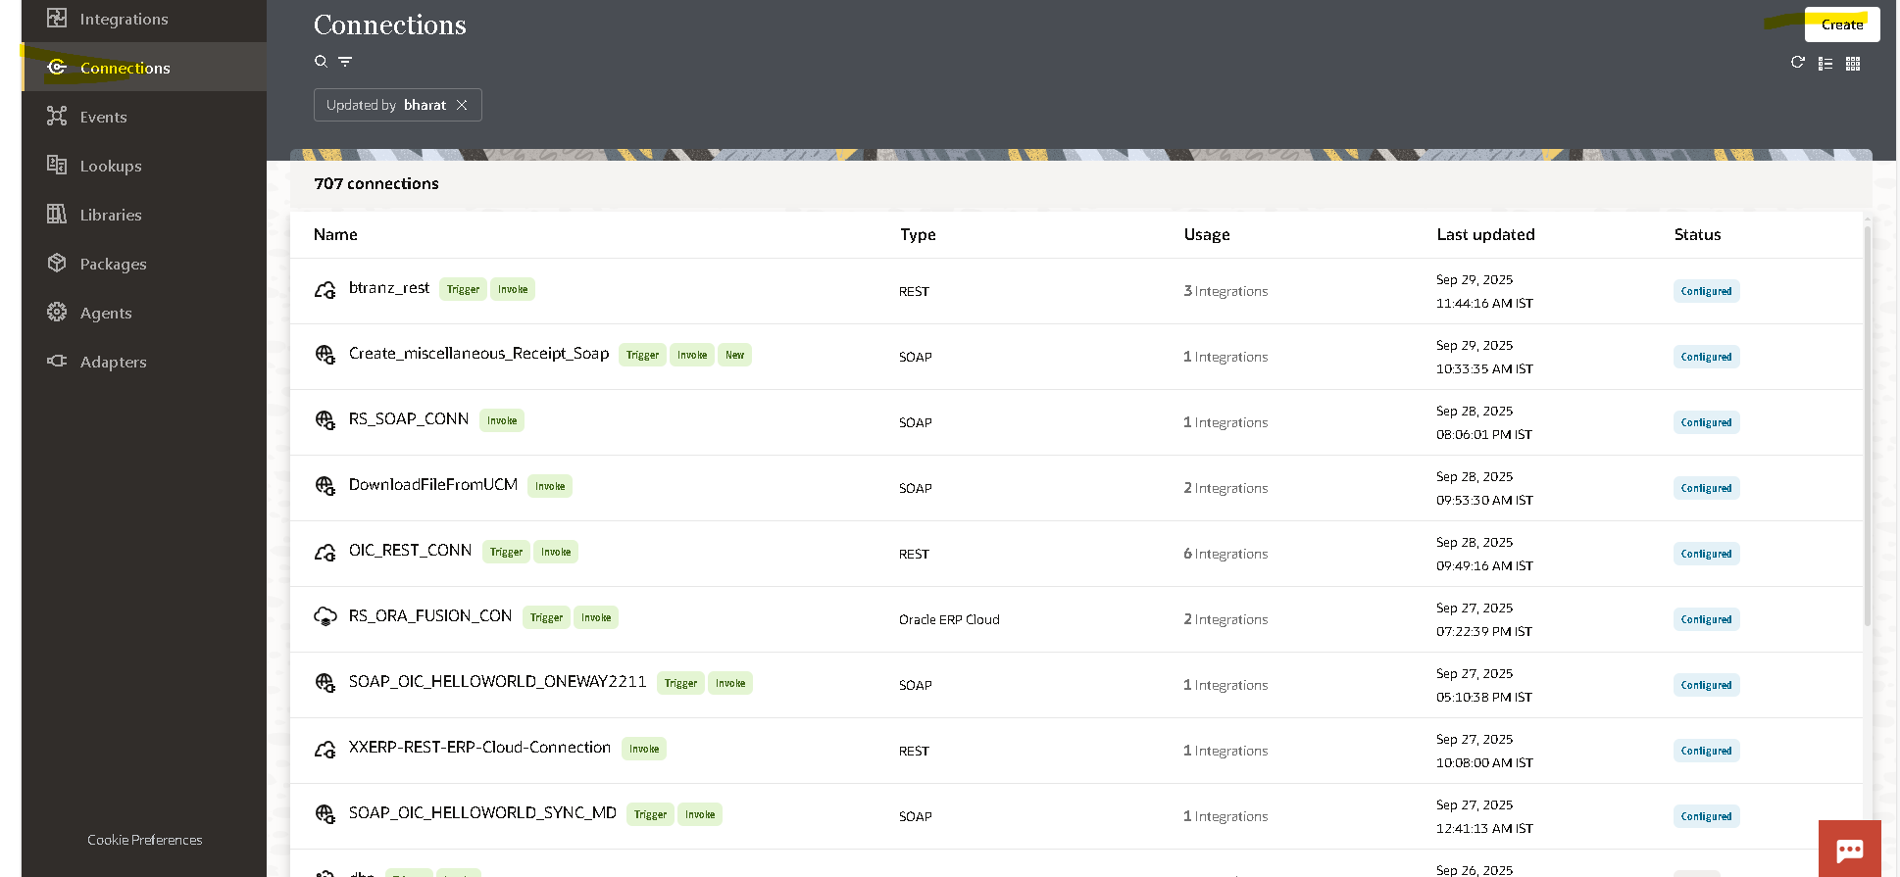
Click on create
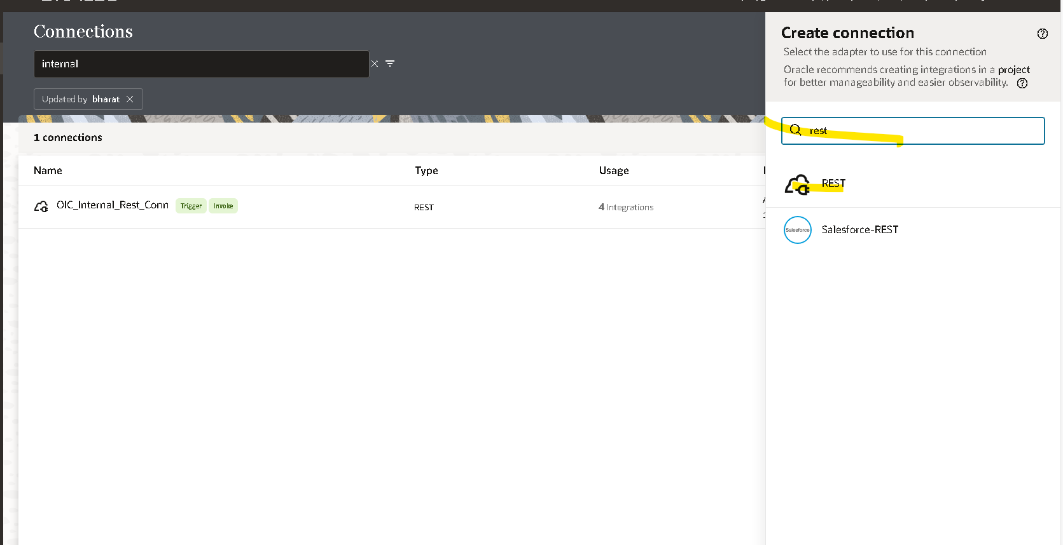
Search for the rest connection
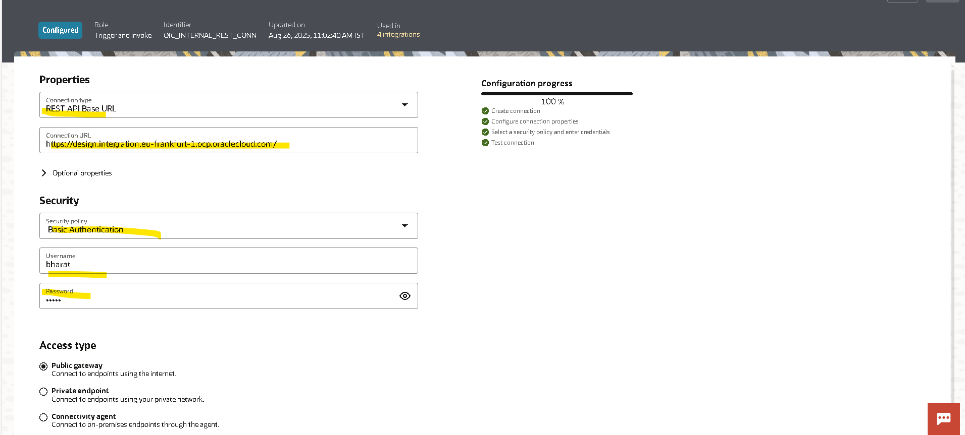

2. Create FTP connection
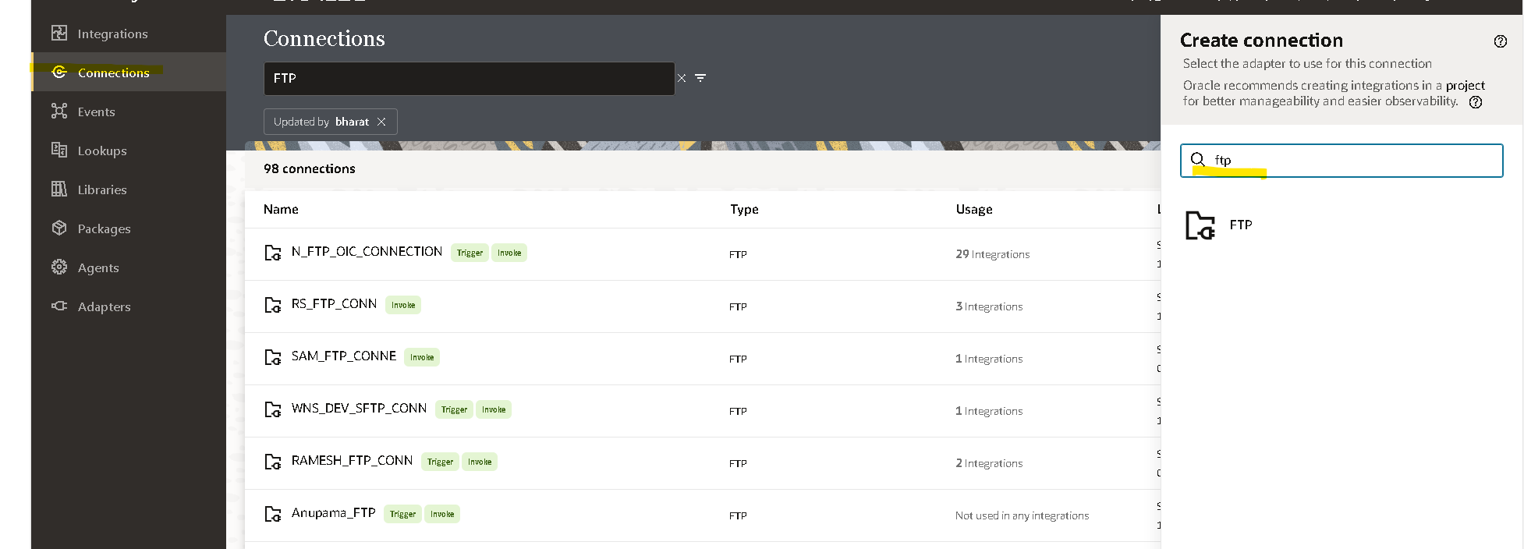
Create integration
Click on create integration
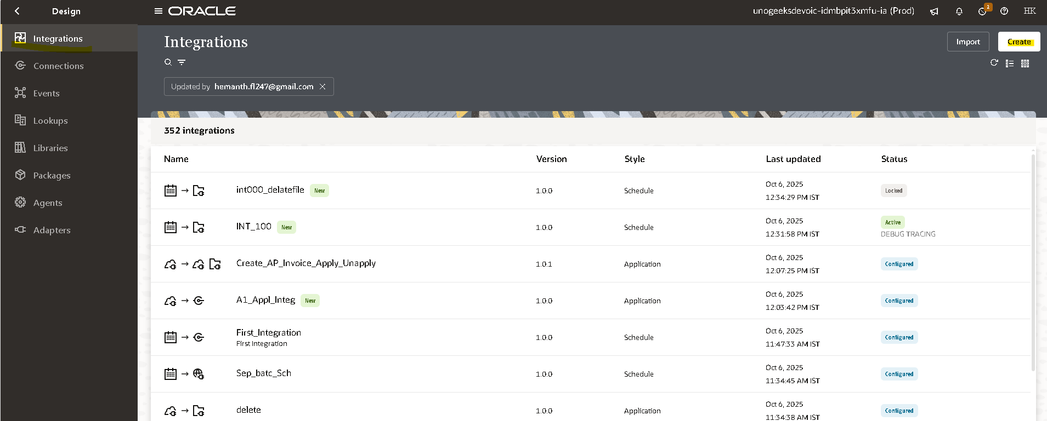

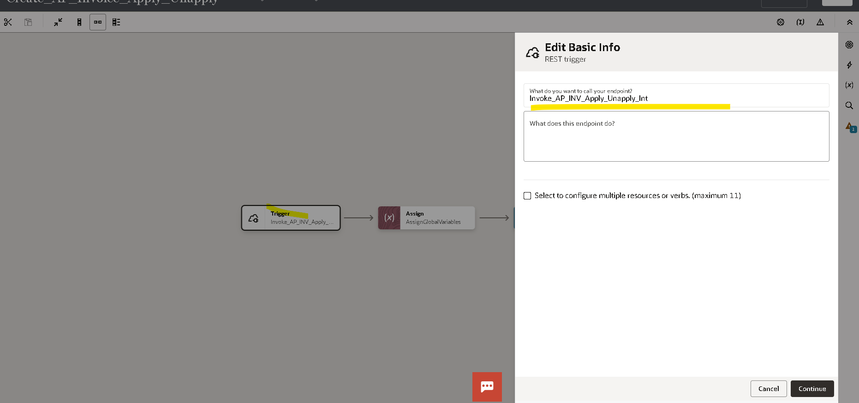
Create the rest Api
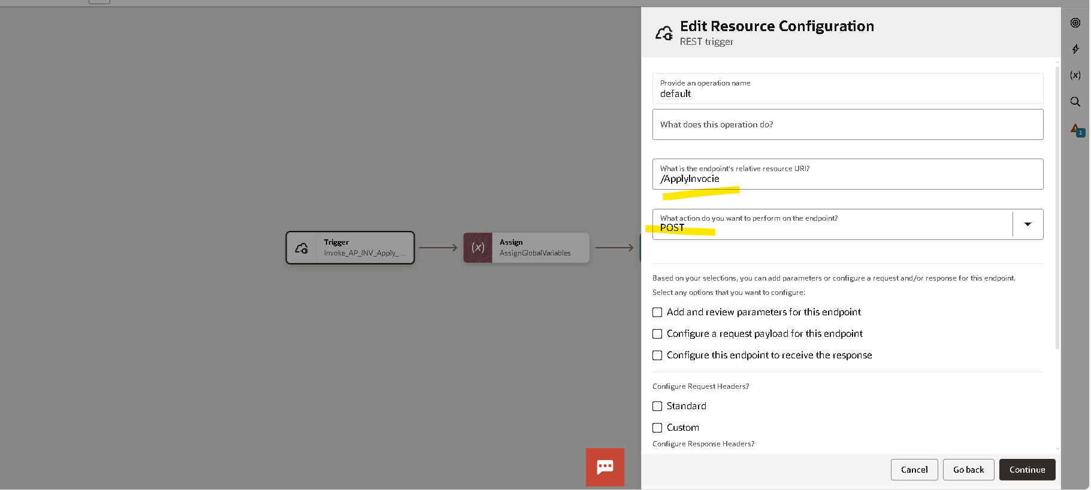
Give a
- Instance URL
- The Endpoint
Assigning the variables
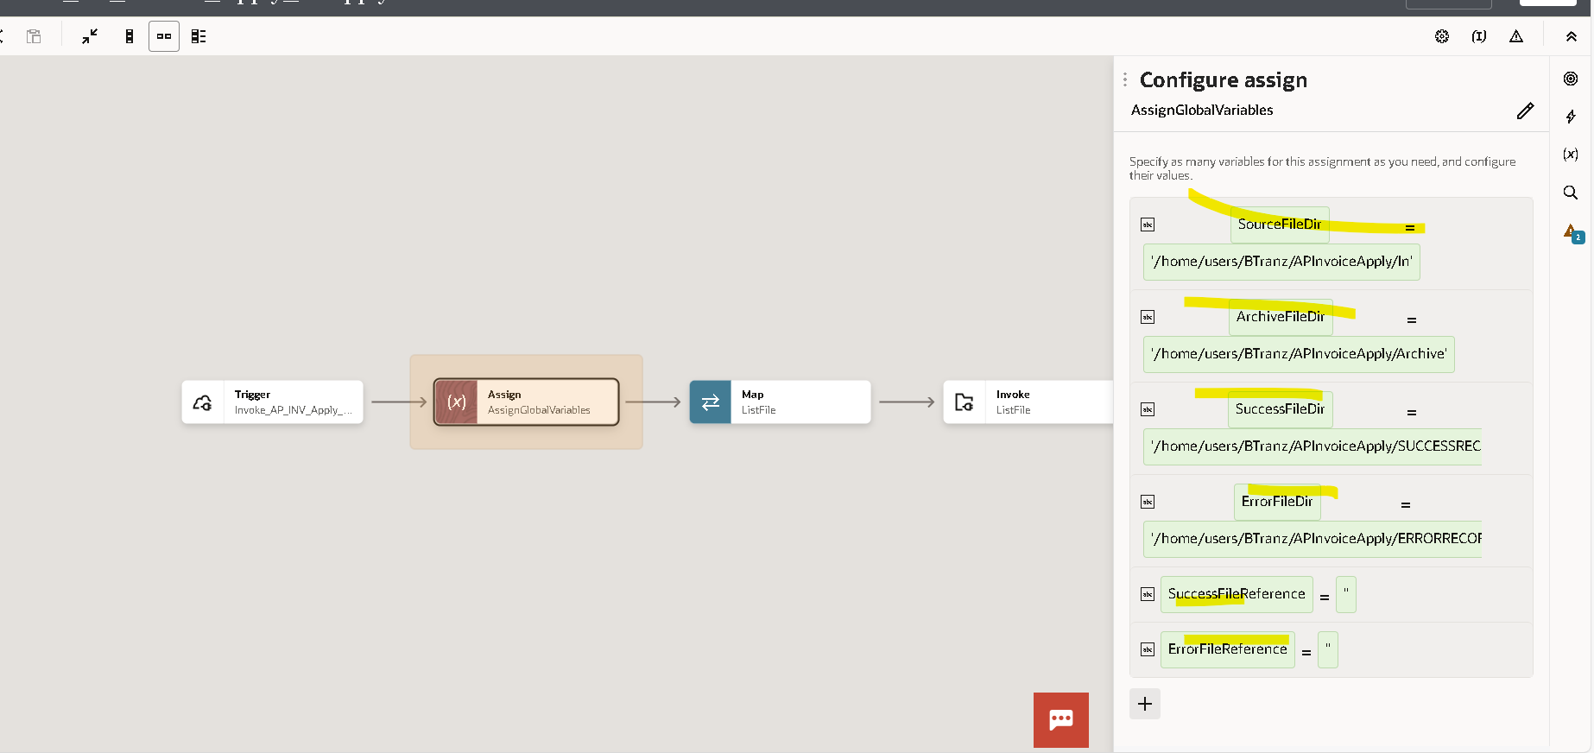
- Source File Directory
- Achieve file Directory
- Success File Directory
- Error File Directory
- Success File Directory
- Error File Reference
- List File By using Stage File
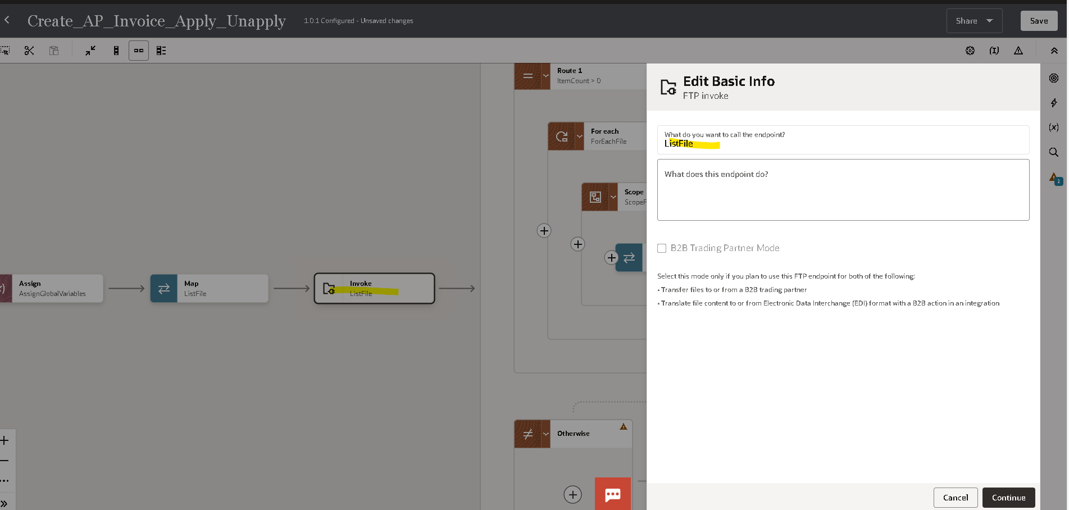
- Select operation as List File
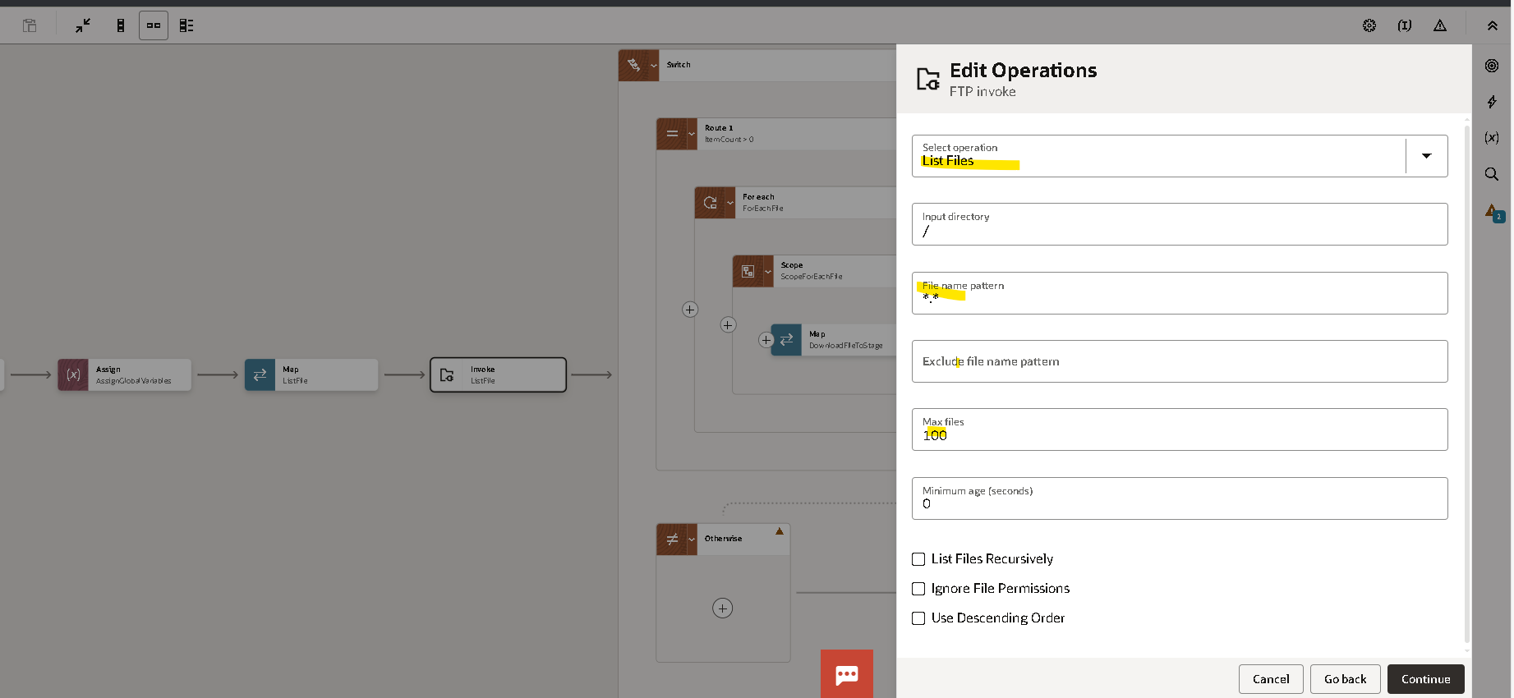
- File name pattern
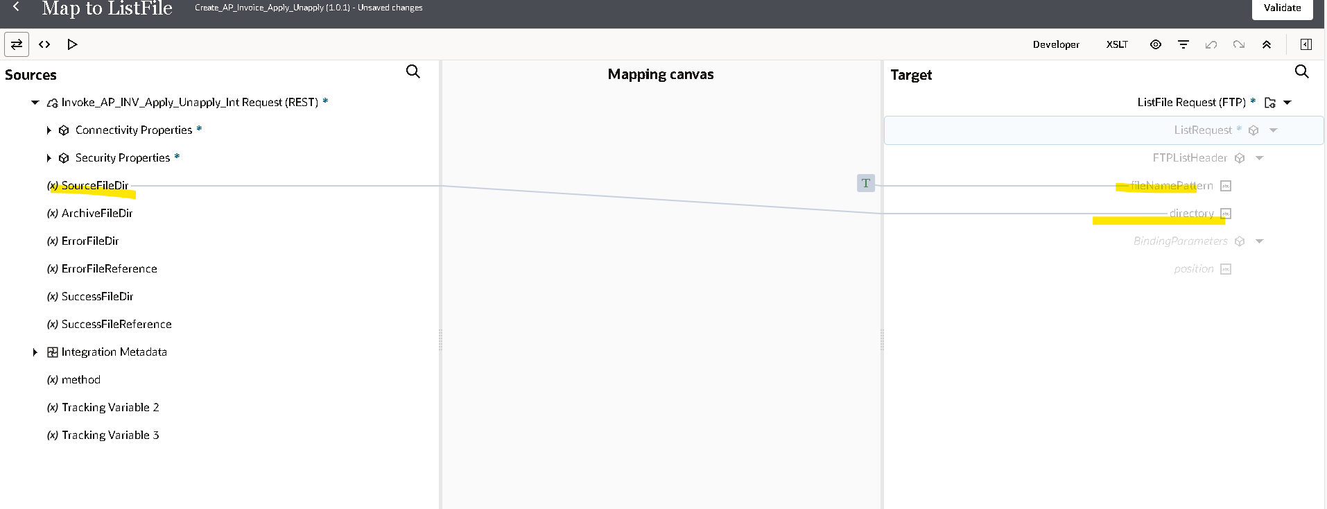
Map
- File Name pattern
- Directory
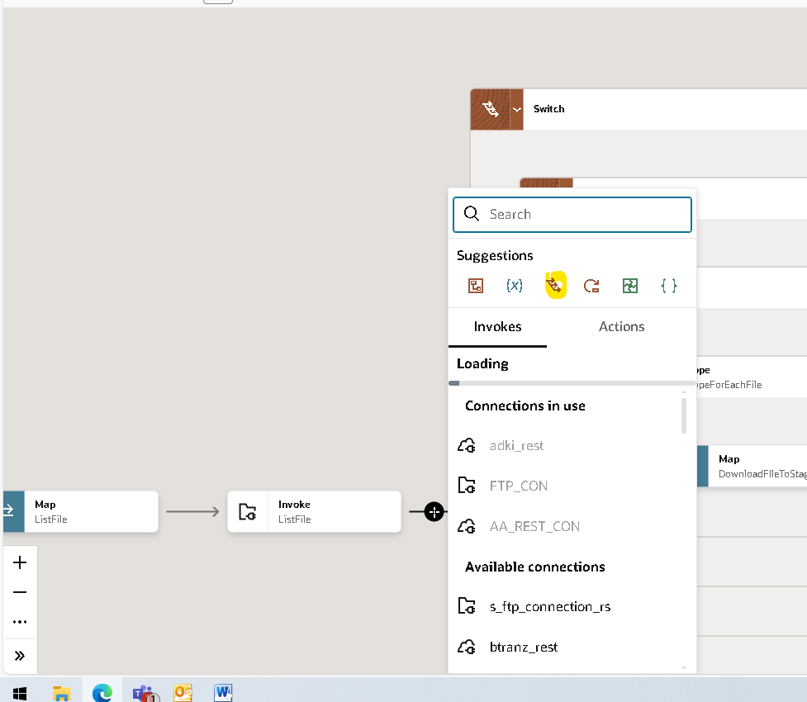
Select Switch
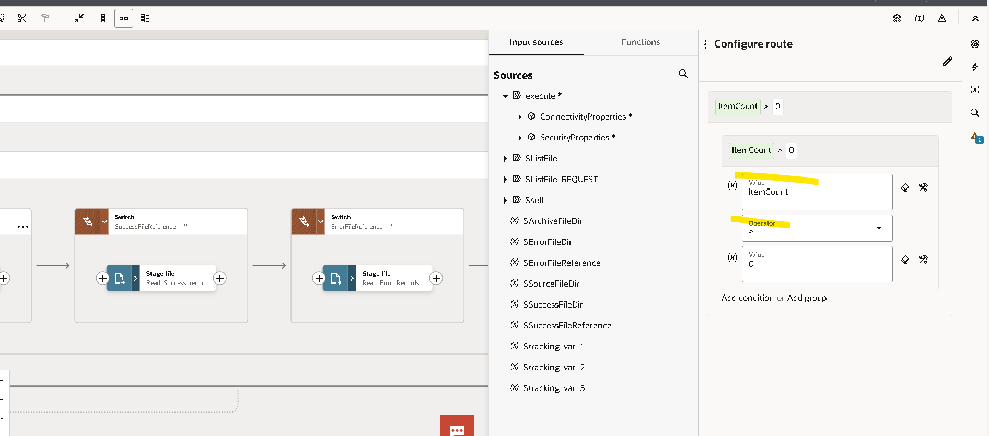
Using Rout
Rout 1 If the File count is >0
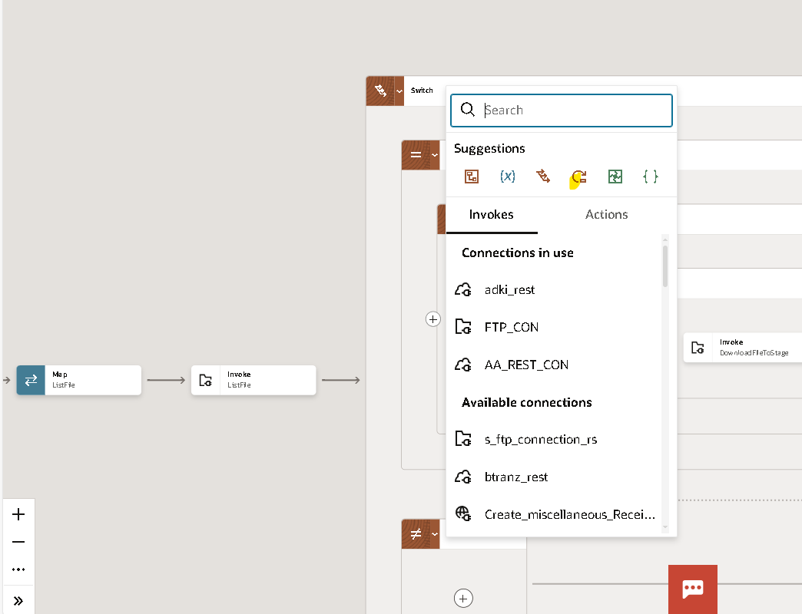
Using For Each
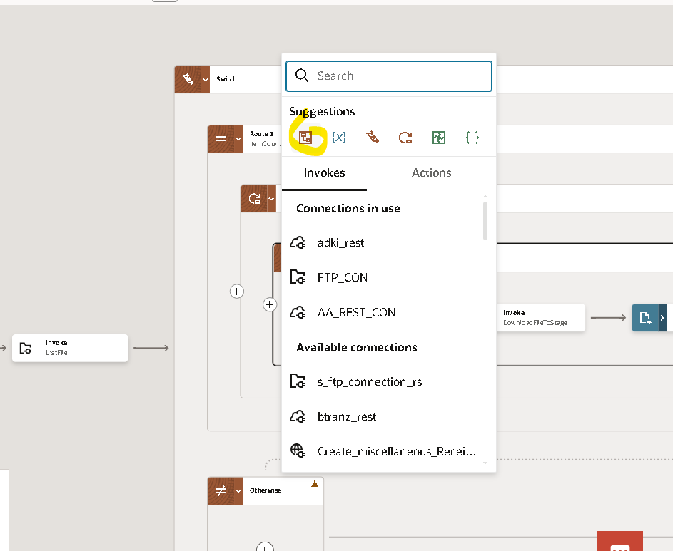
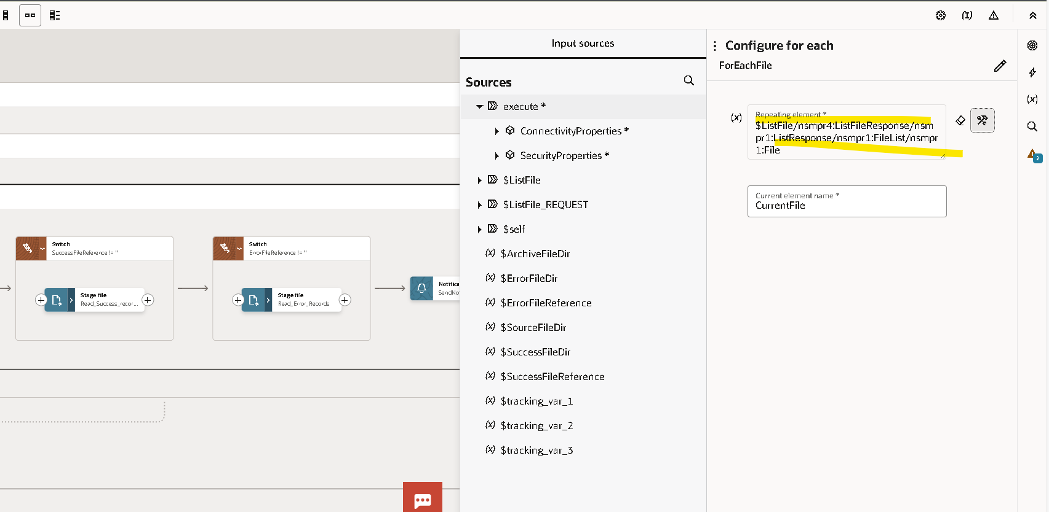
Give a file Reference
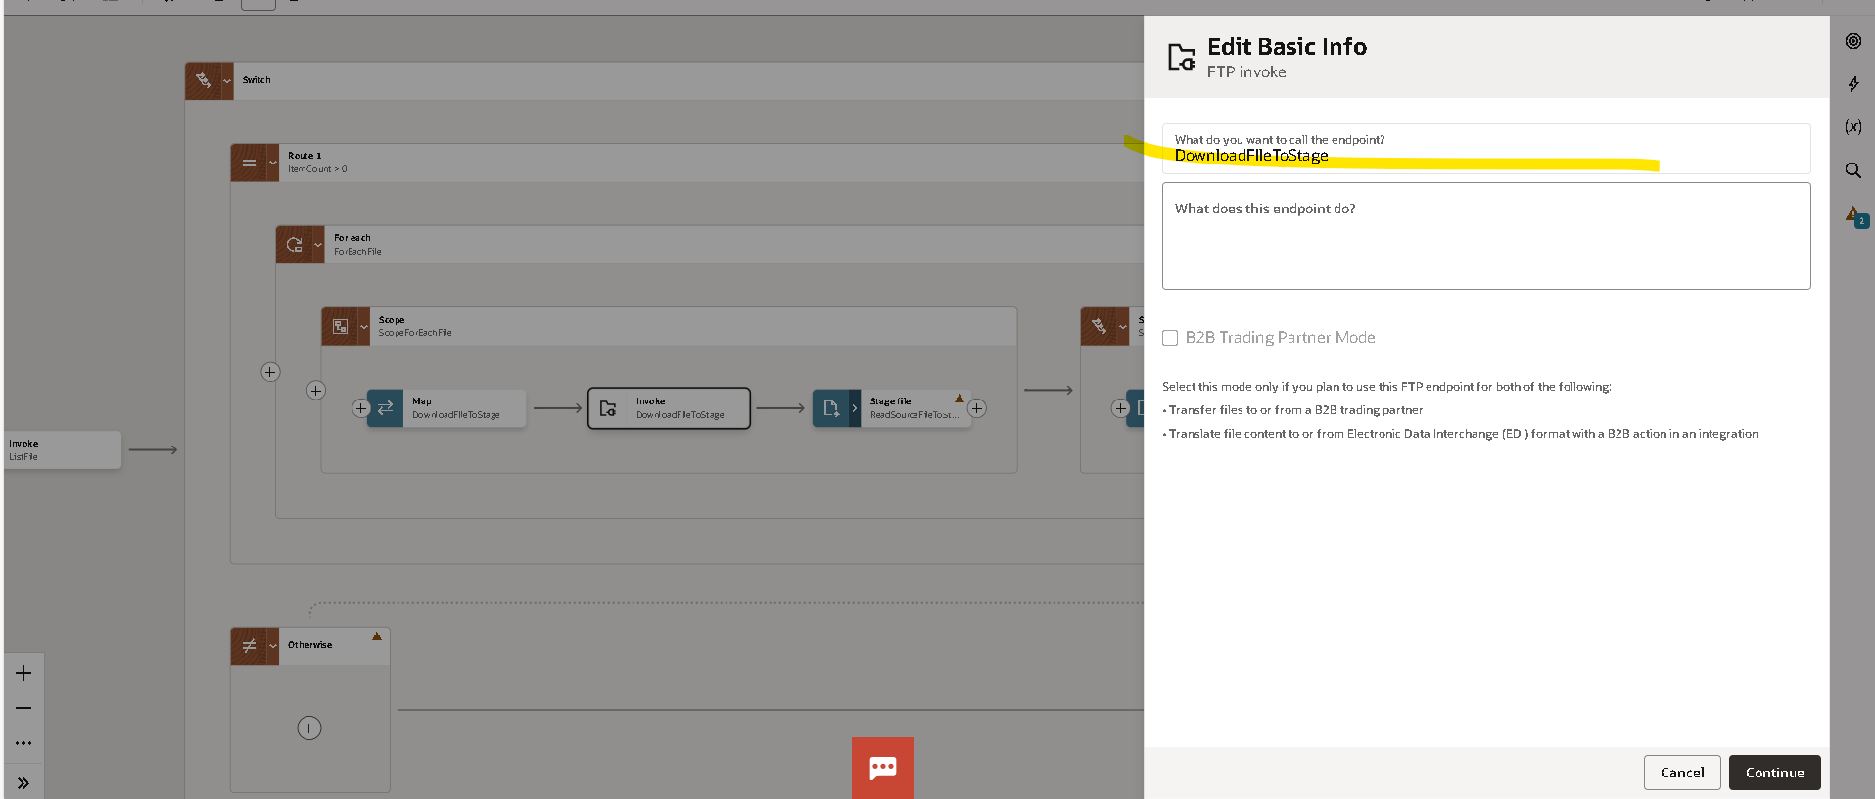
In scope
Using the FTP connection to Download File To Stage
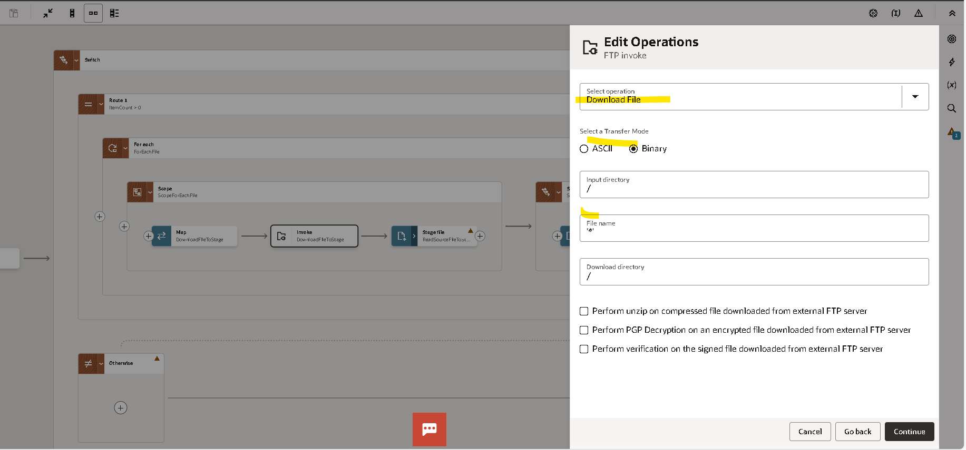
Select Operation as Download File
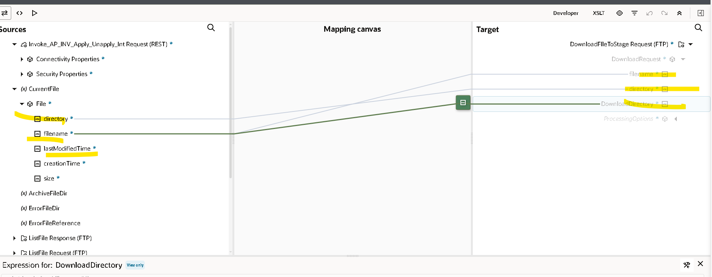
Map
- Directory
- File name
Using stage file
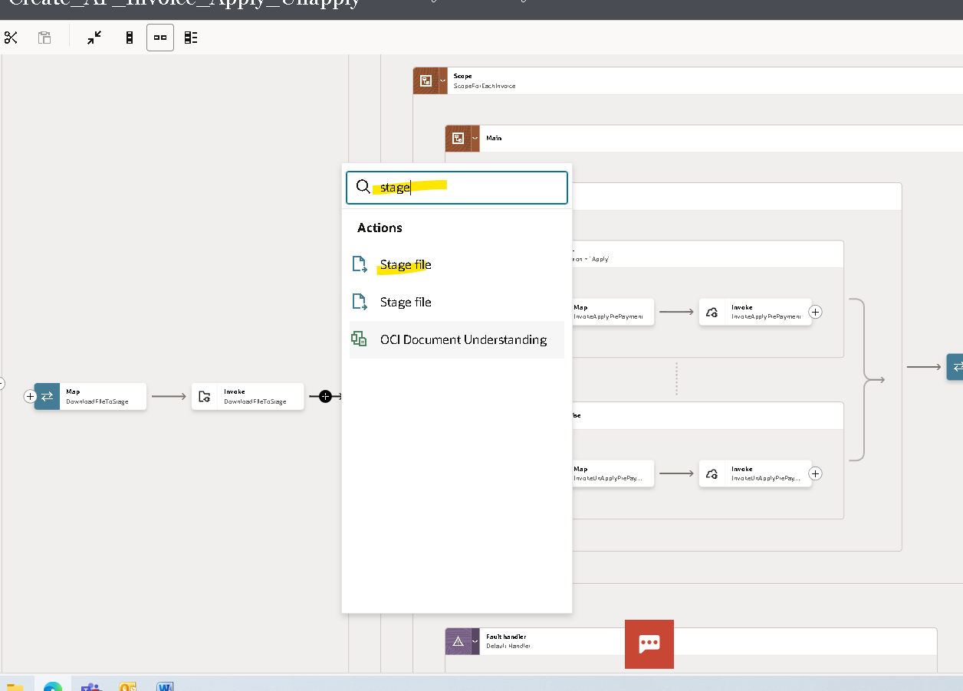

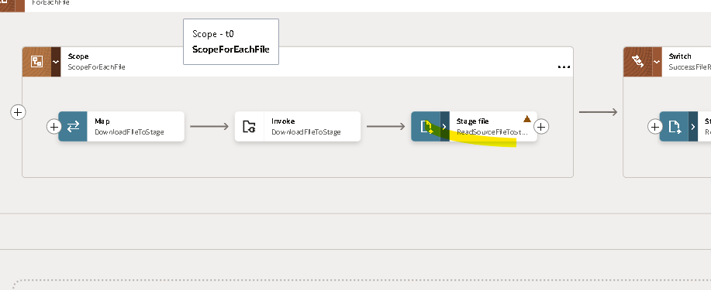
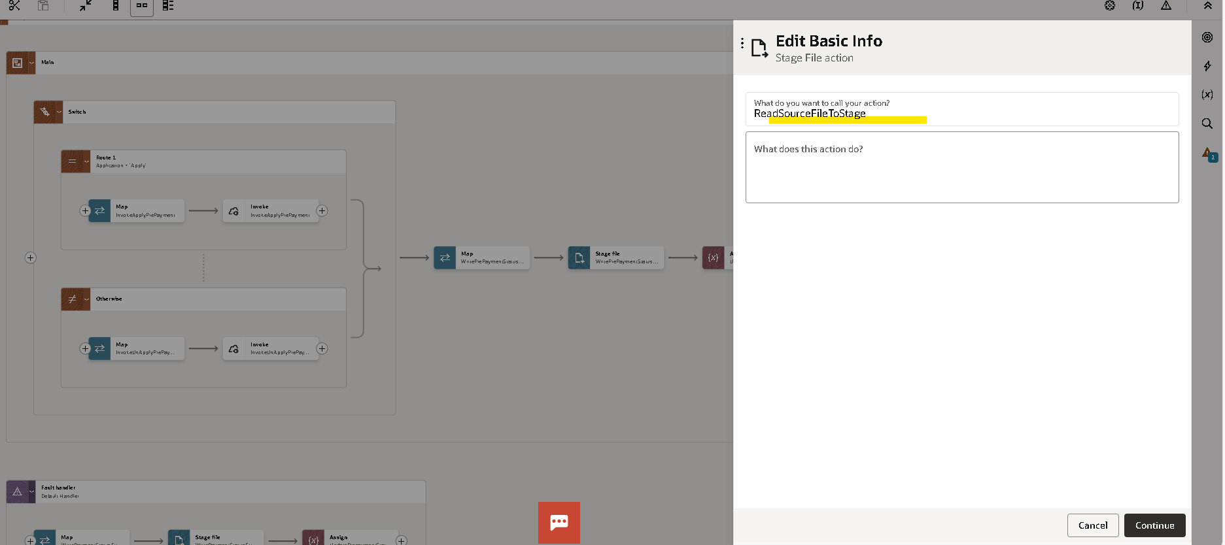
Read Stage file to Stage
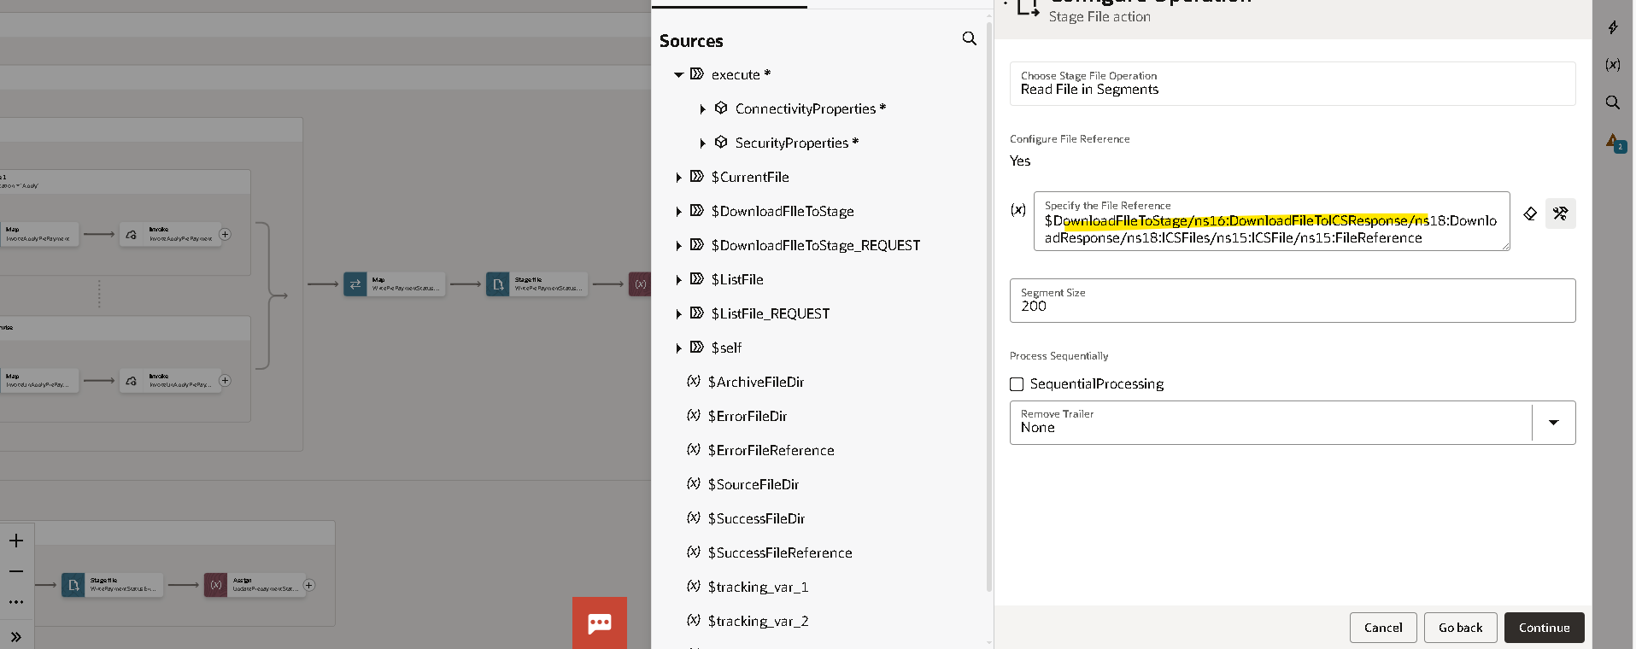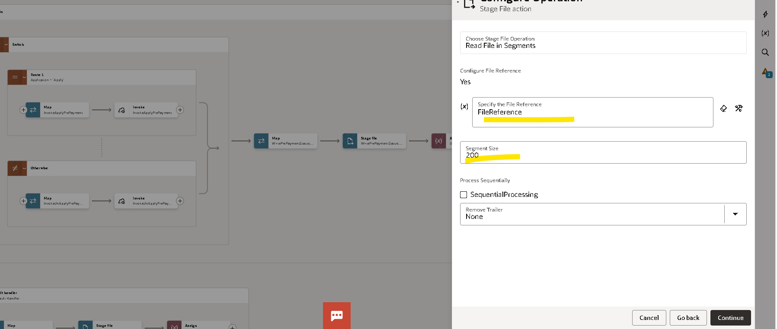
Give File Reference
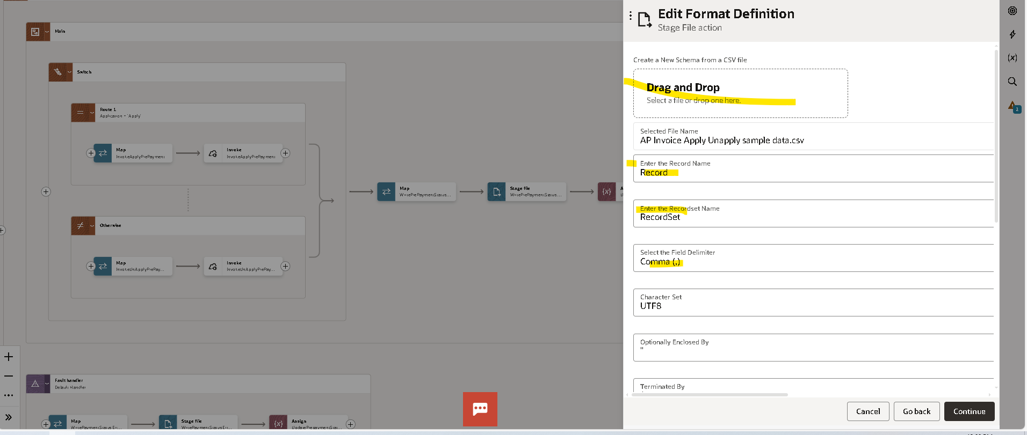
Give Reference File
Using For Each
Give a file reference
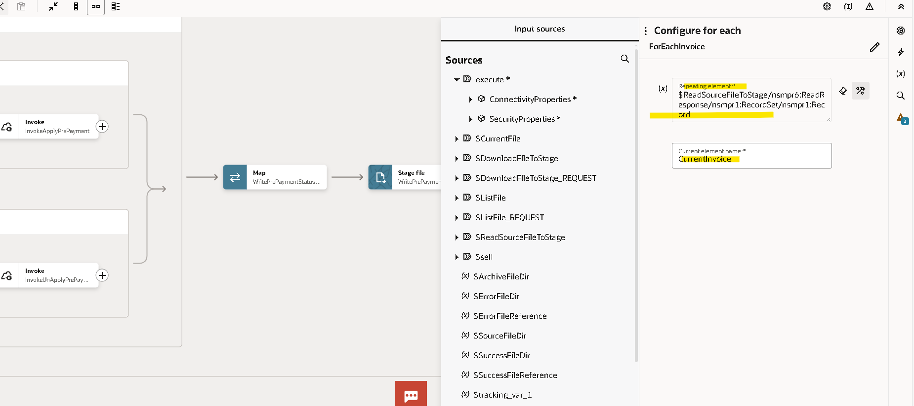

Use Scope
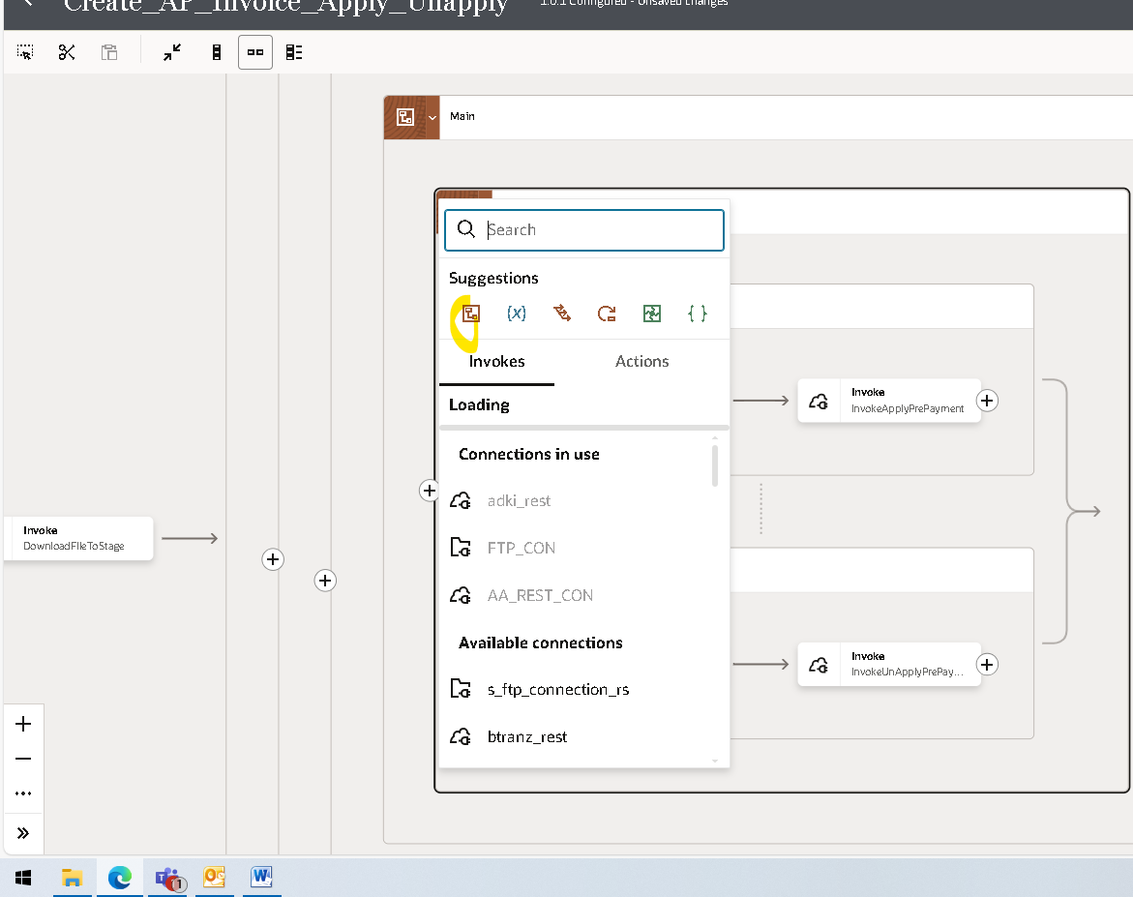
We are Using the Routs
The rout is for If the invoice is unapplied
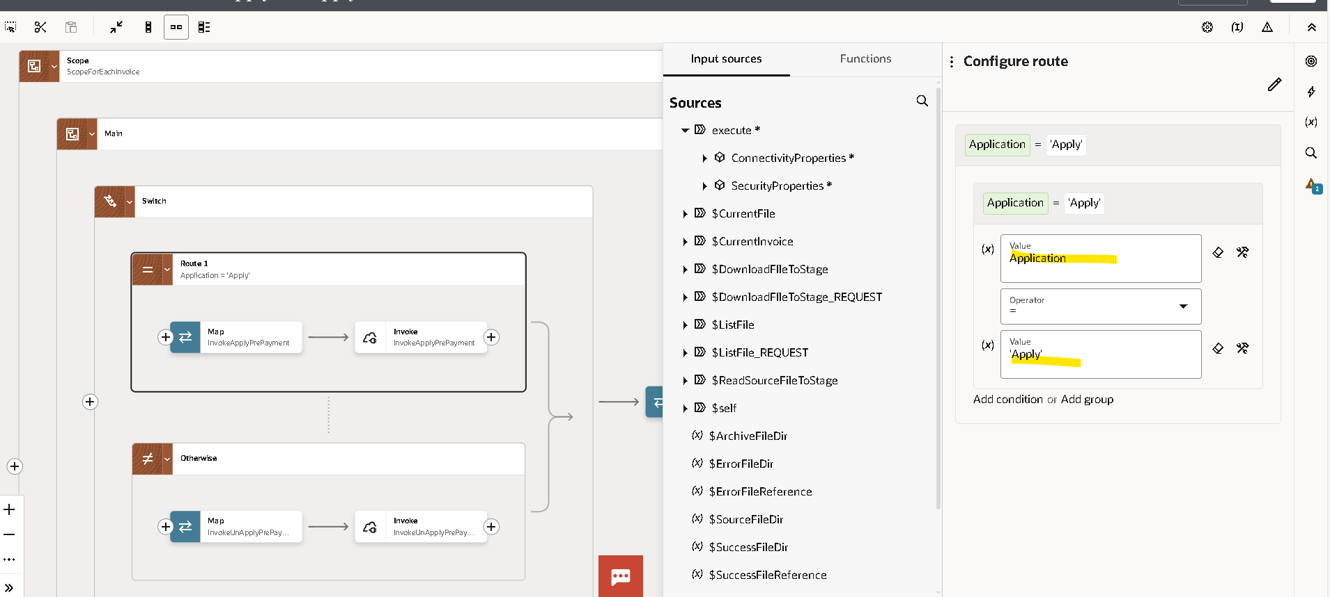
If the value application=Apply then
Using rest api to post the values if the application=apply
Give Relative source URL

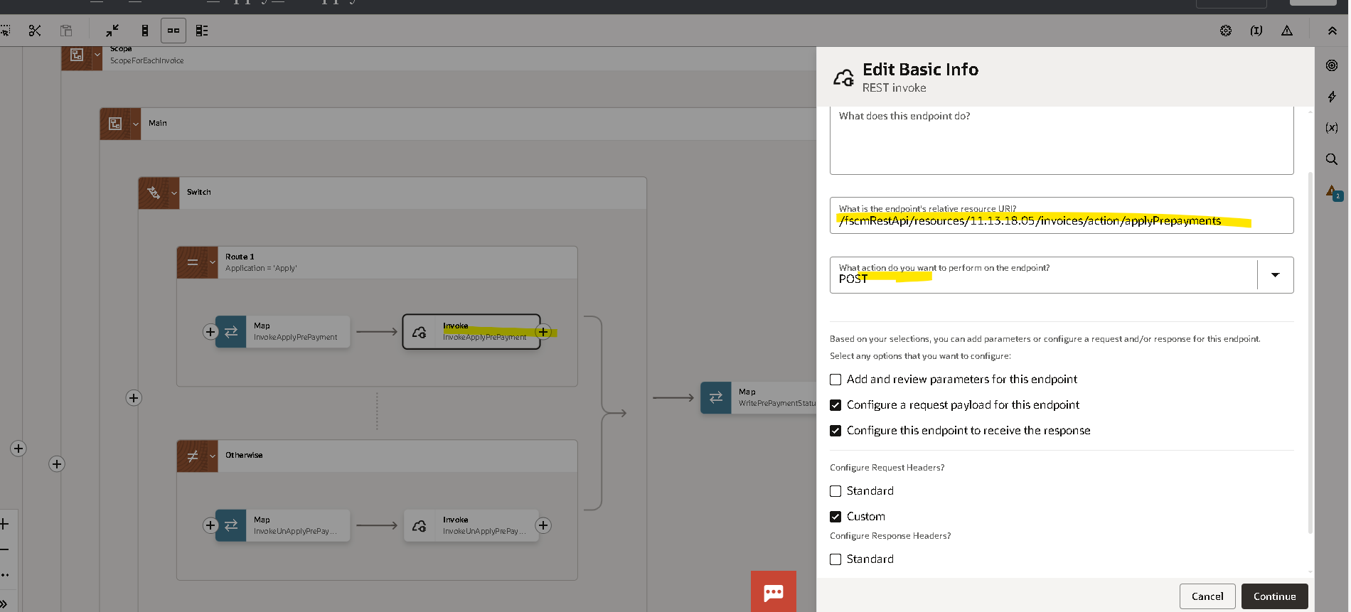
Give the Inline
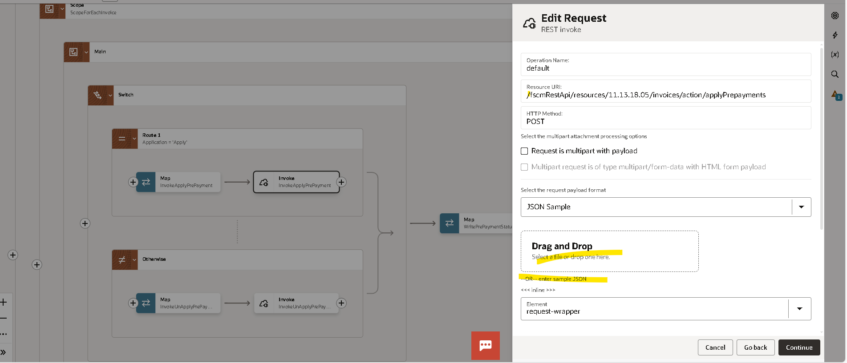
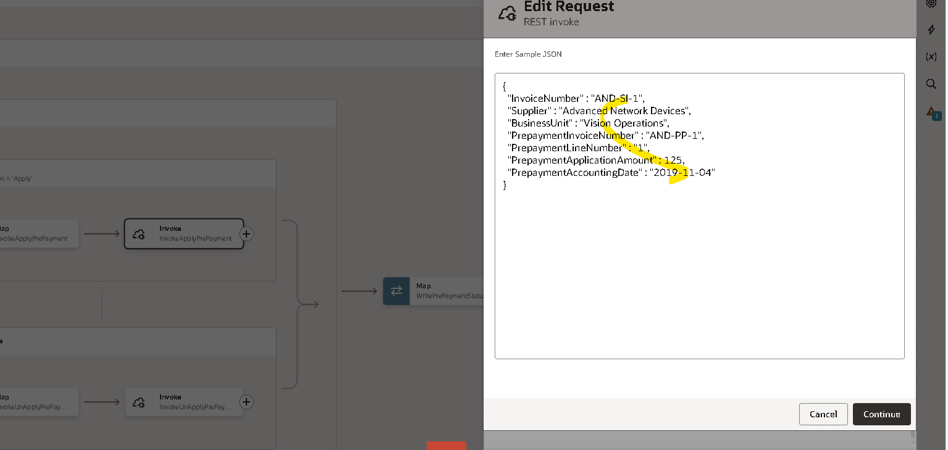
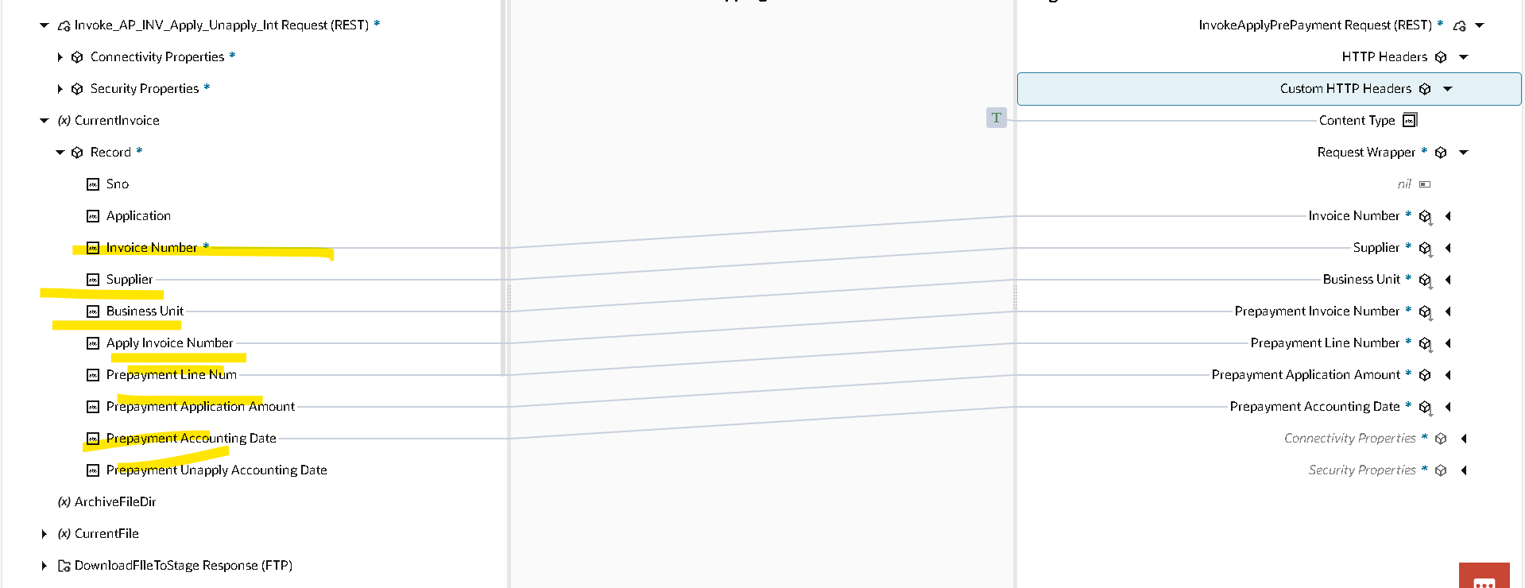
Map the Data
Using Otherwise If the Application is != Apply
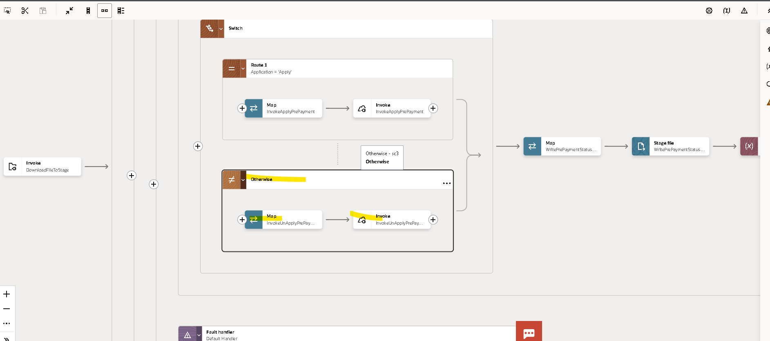

Using the rest Connection
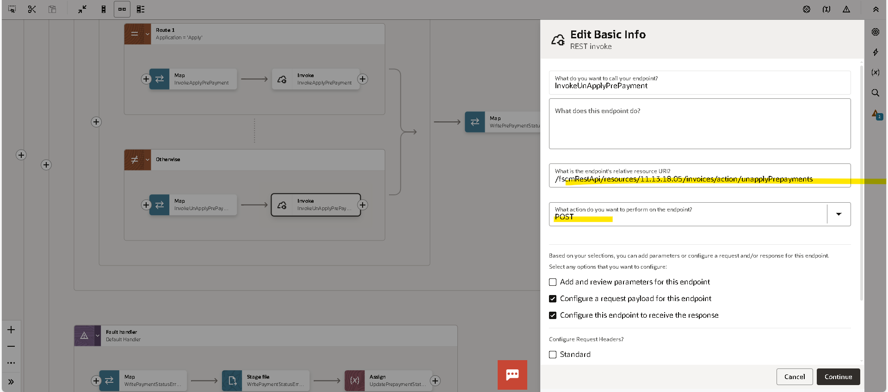
- End point
- Resource URL
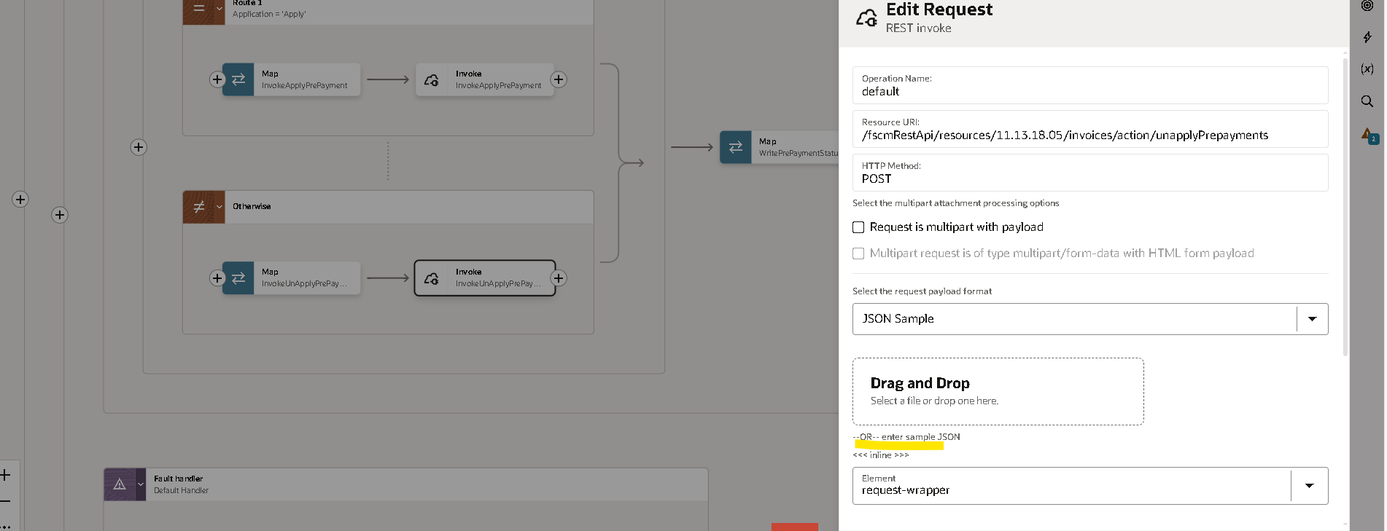
Give a inline
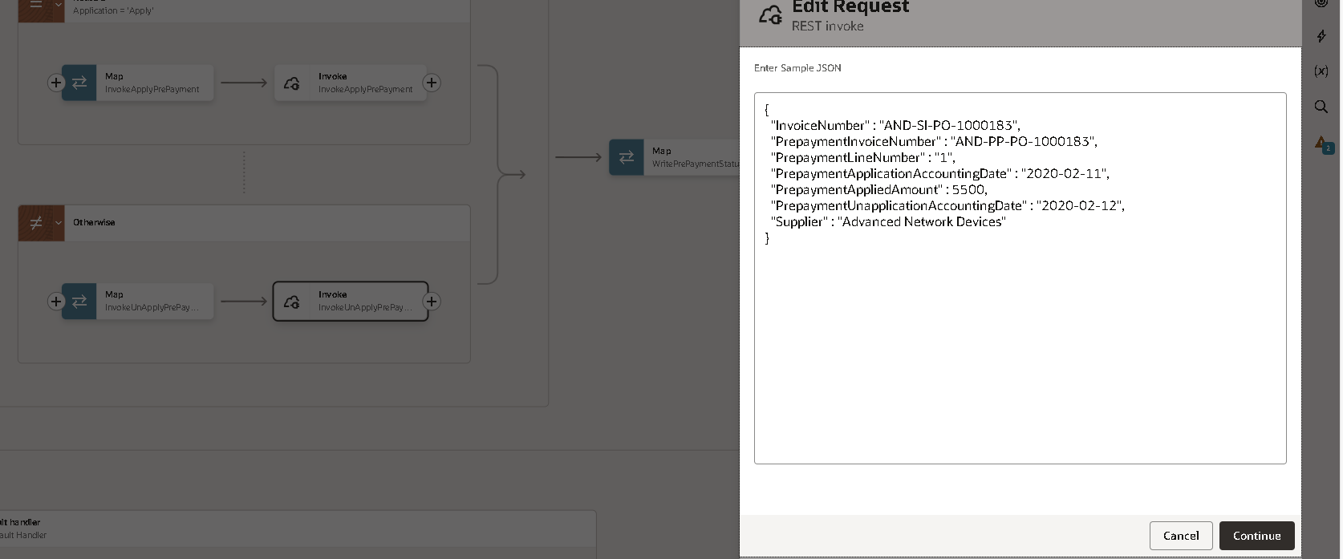
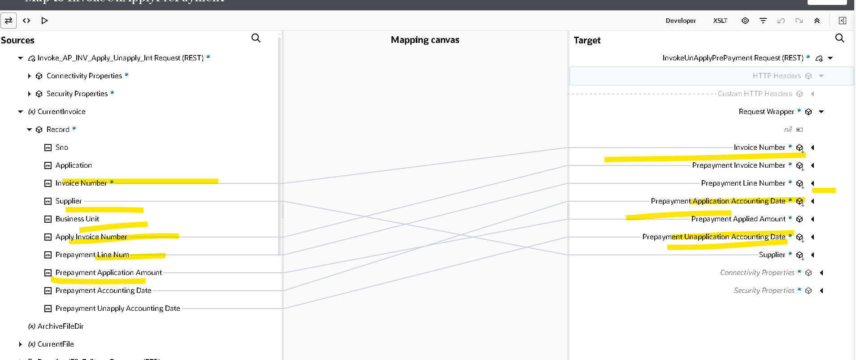
Map the Data
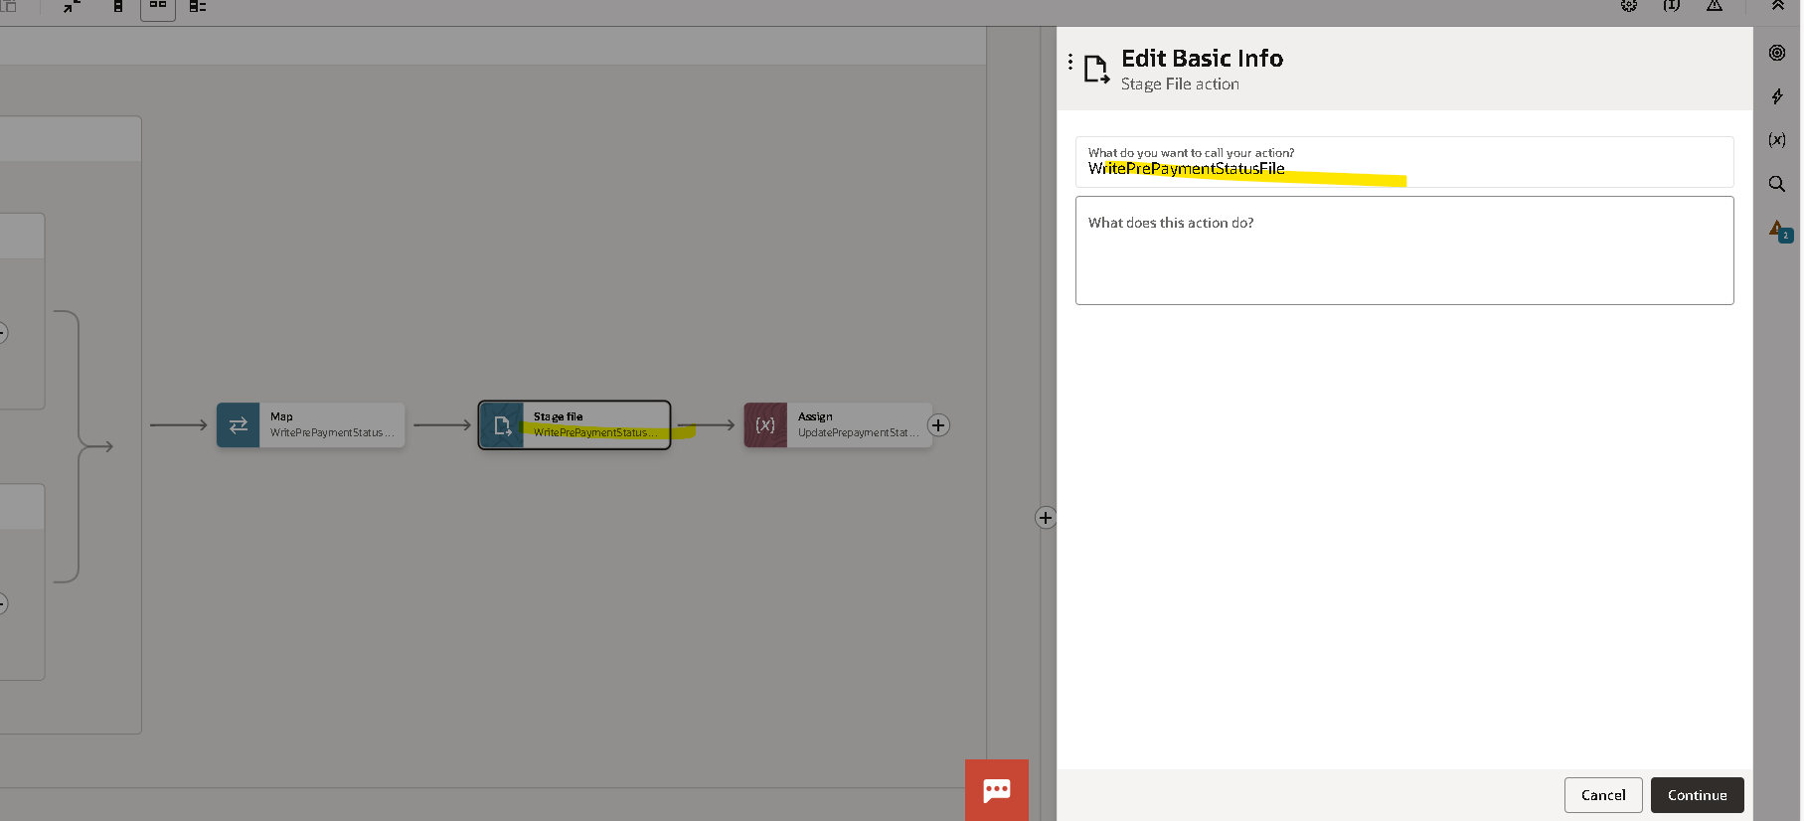
Using the stage File to Write the File in SFTP
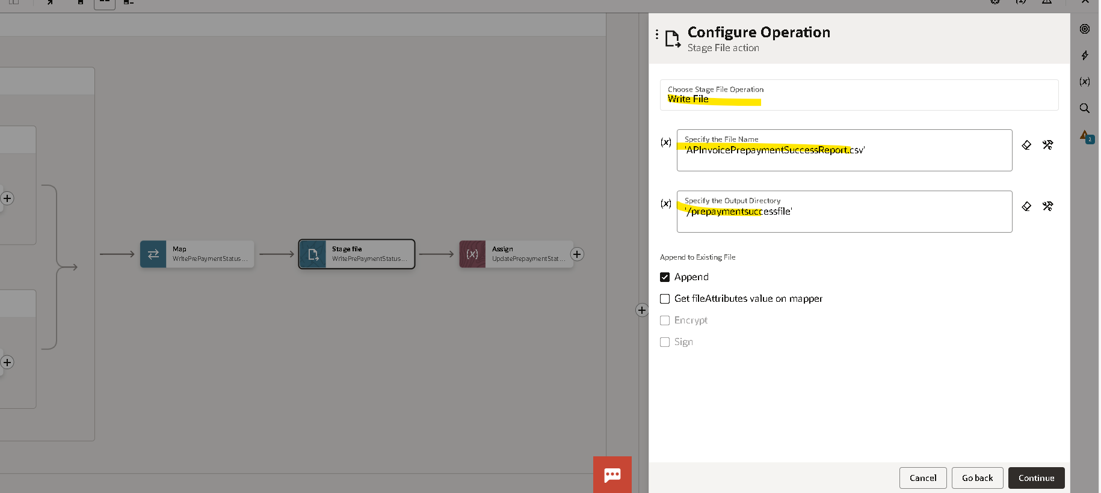
- Give the File Name
- The Out Put Directory
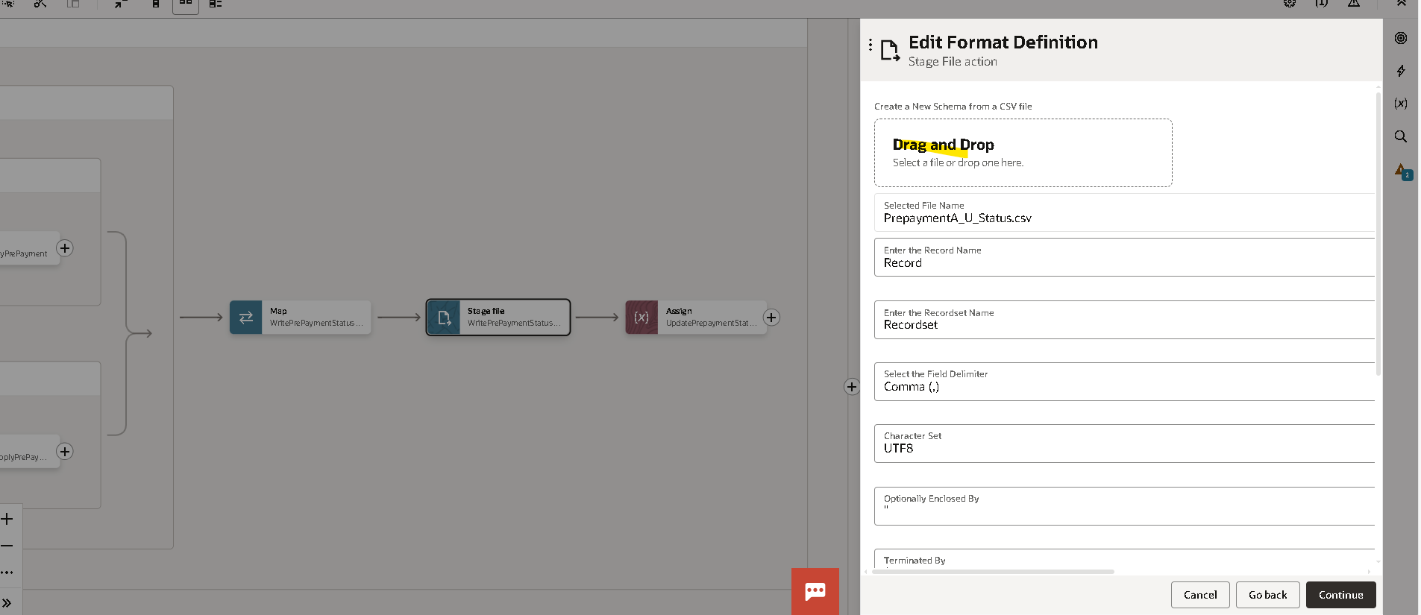
Give a file reference

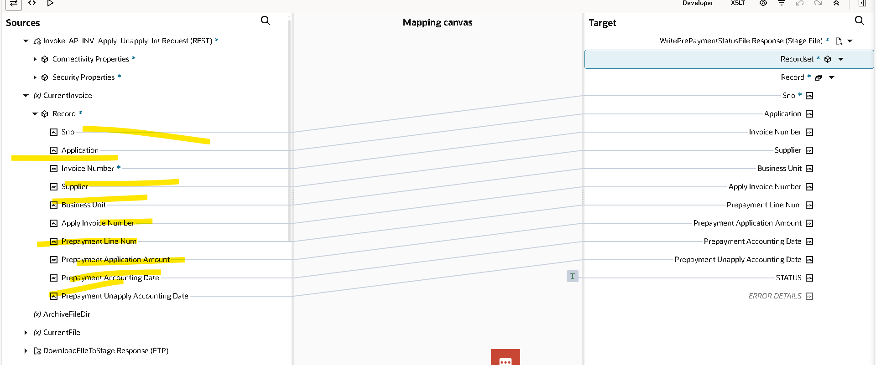
Map the Data
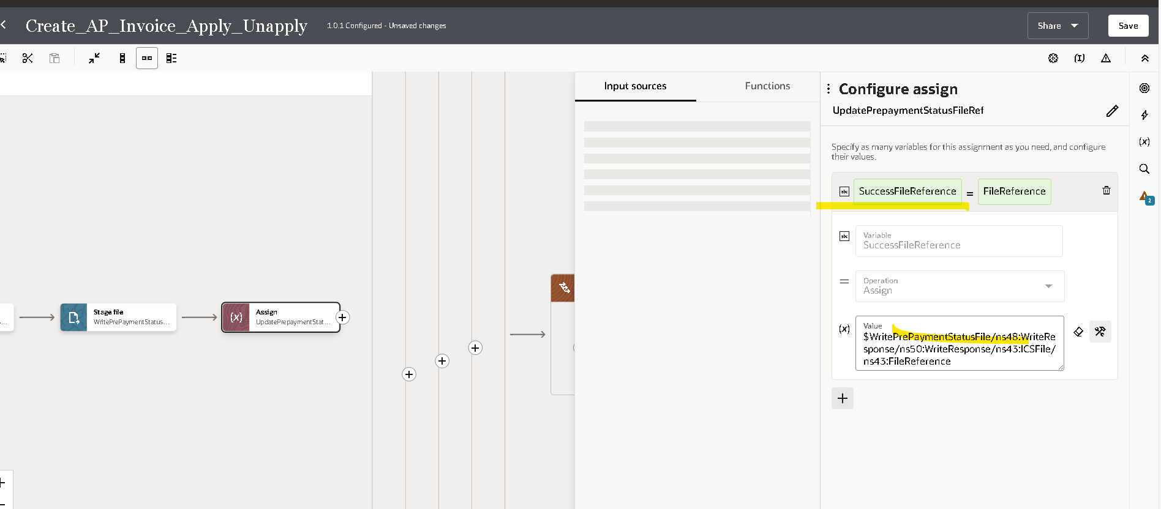
Assign the Variable
- Success File Reference
- Fault Handler
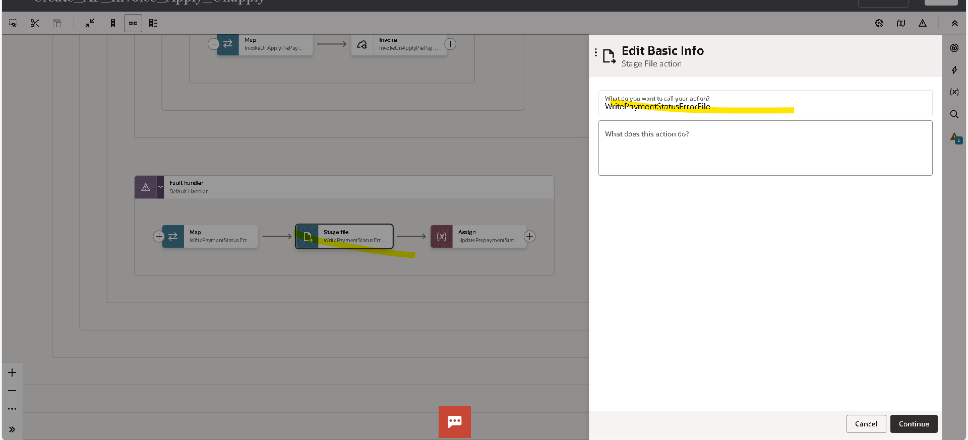
Using the stage file to store the error file in SFTP Server
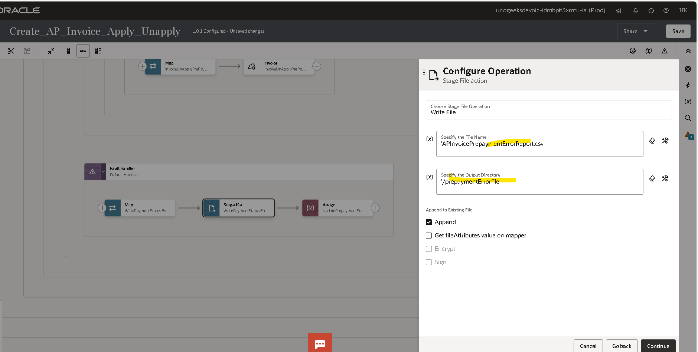
- Give a file name
- Specify the Output Directory
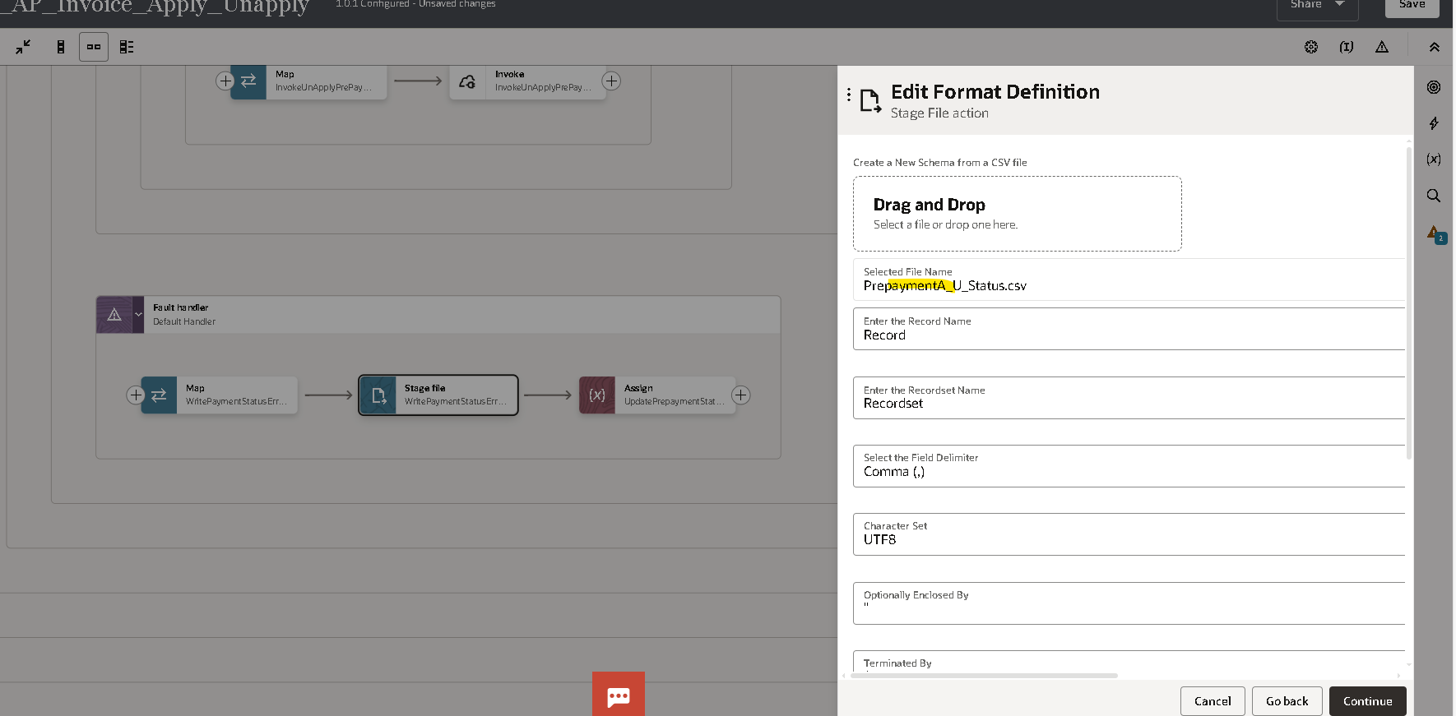
- Give a file reference
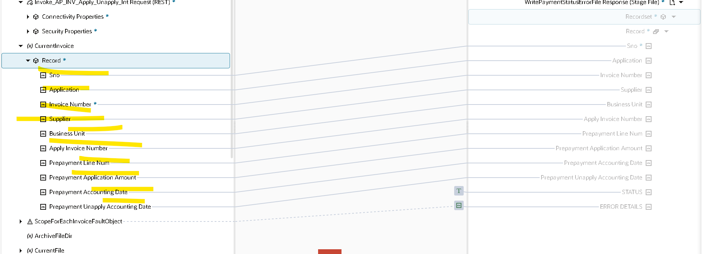
Map the data
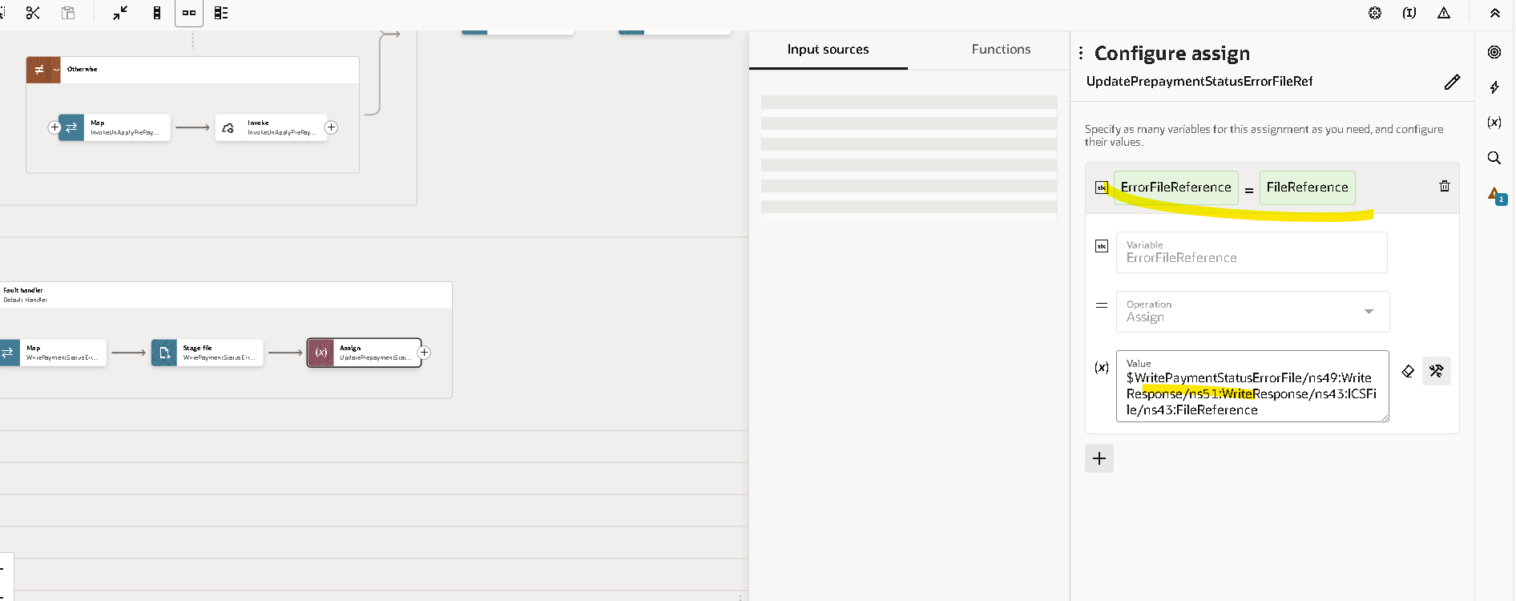
- Assign the Variable for Error file reference
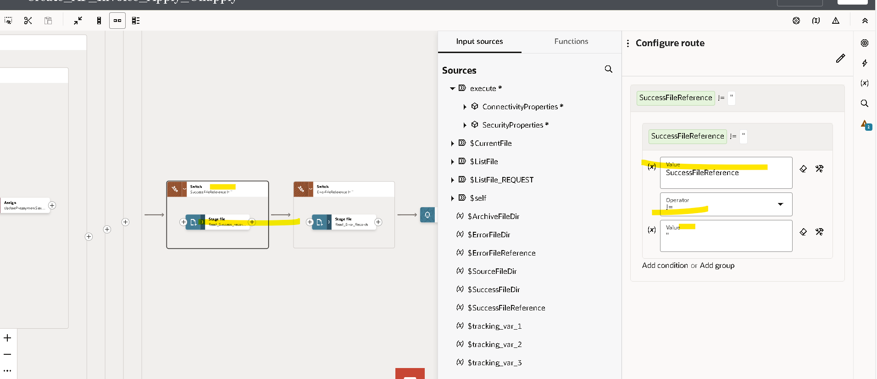

Using Switch
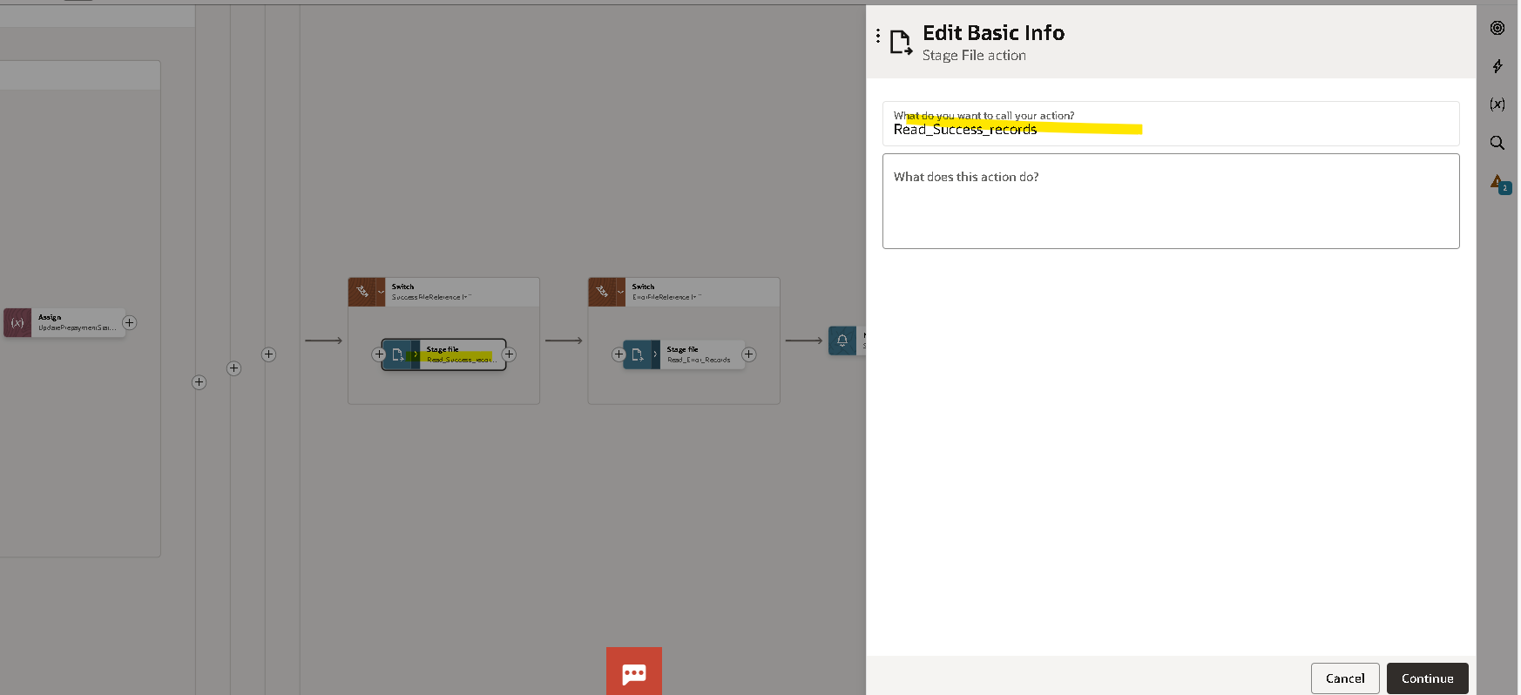
Read File using the Stage File For Success records
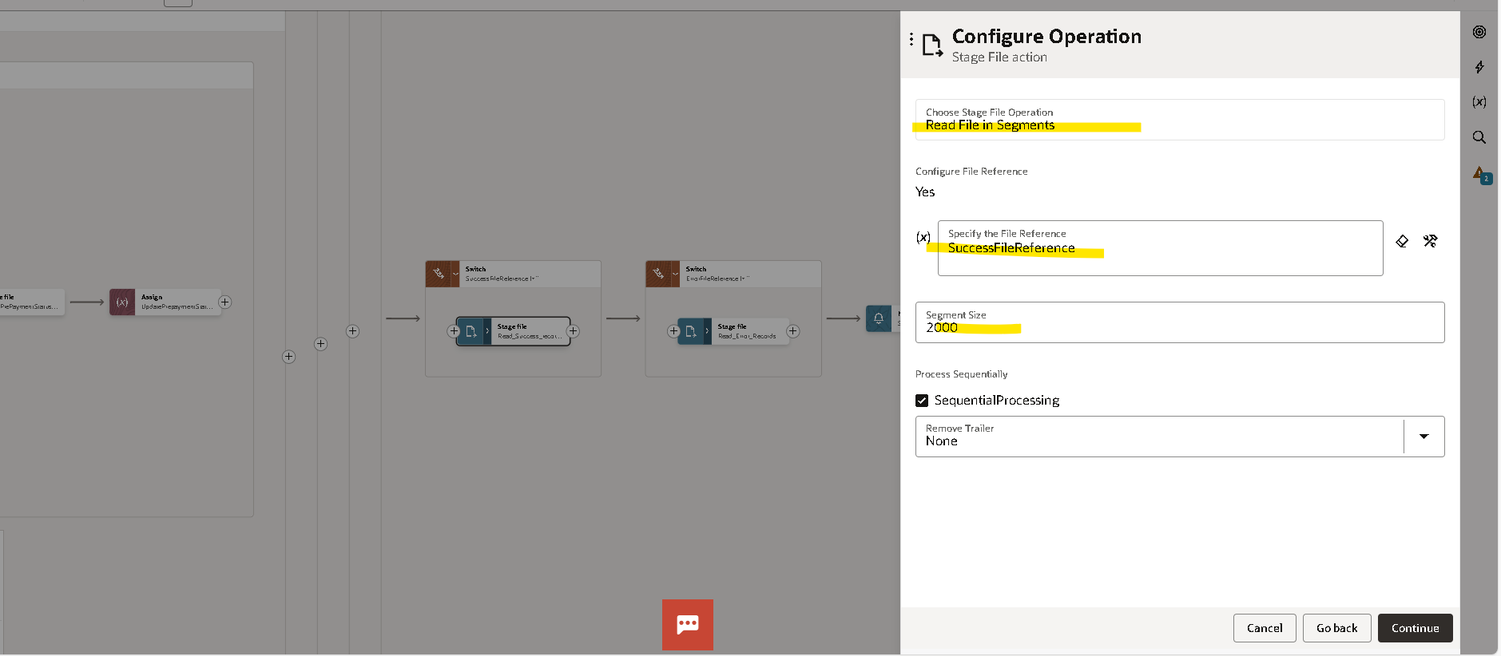
Give a file reference
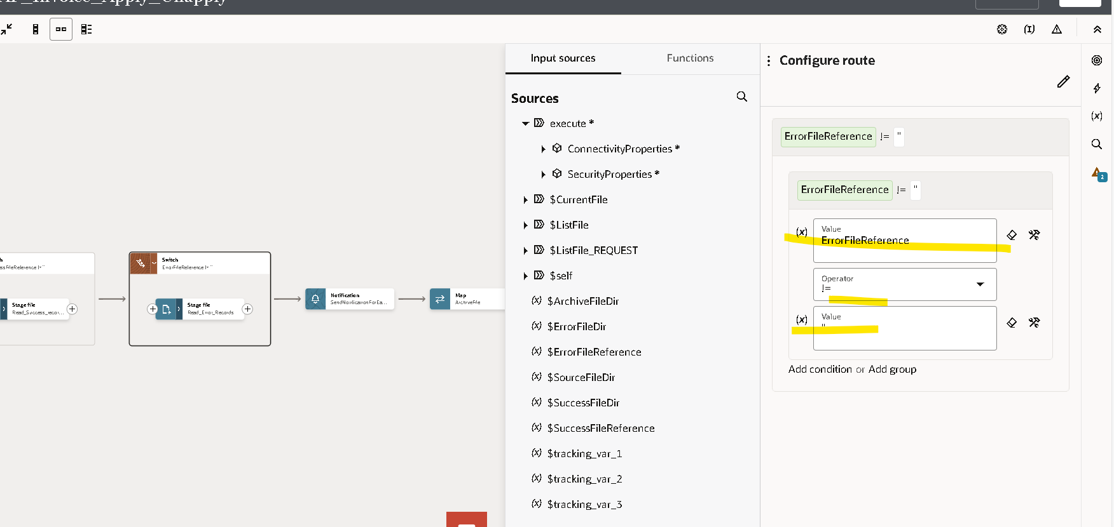
And same for error file
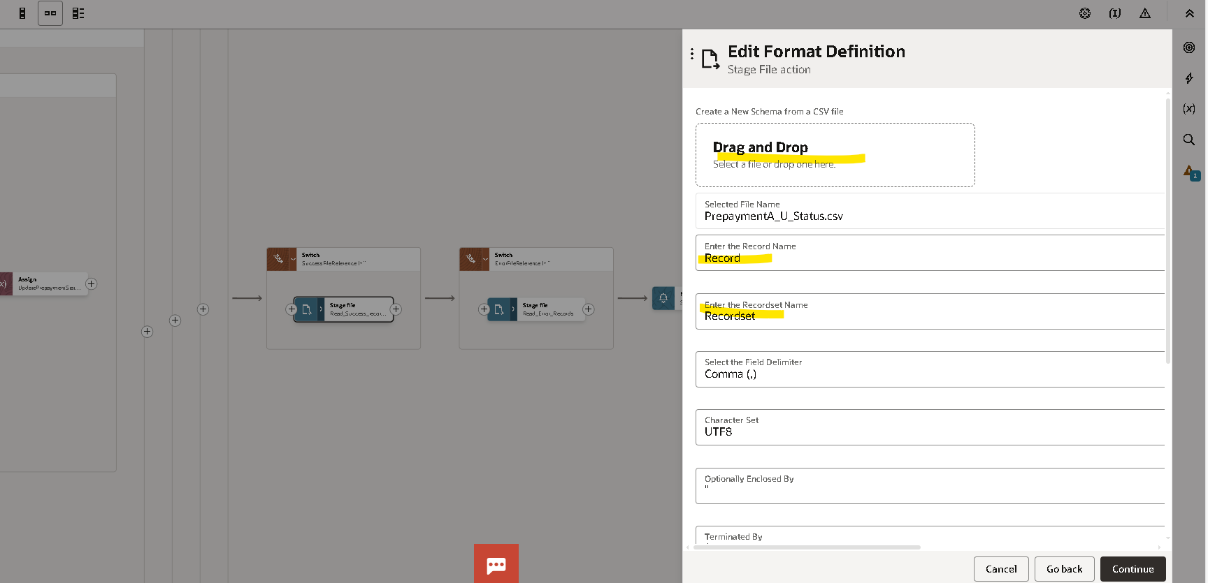
Attach the reference file
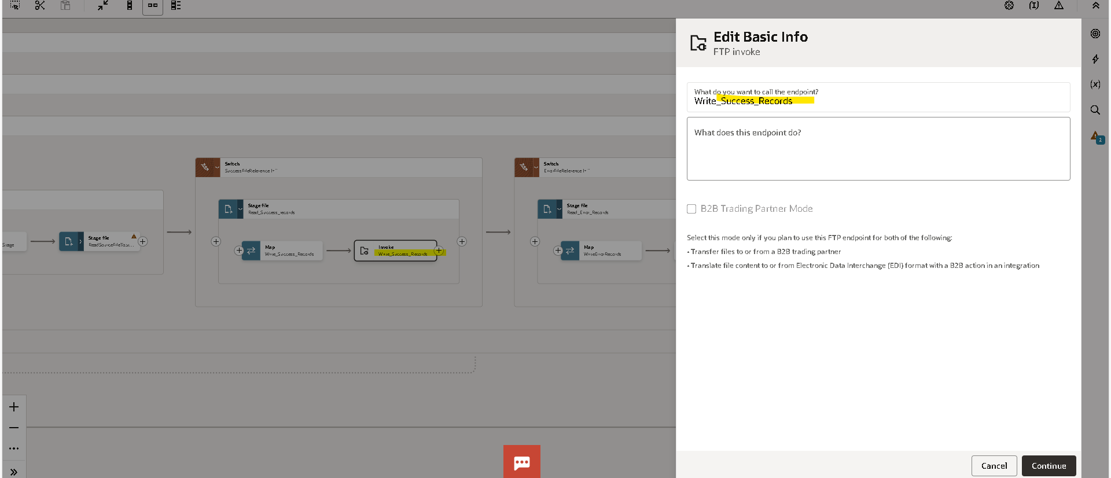
In the Success read success file
Using FTP connection to read the Success file
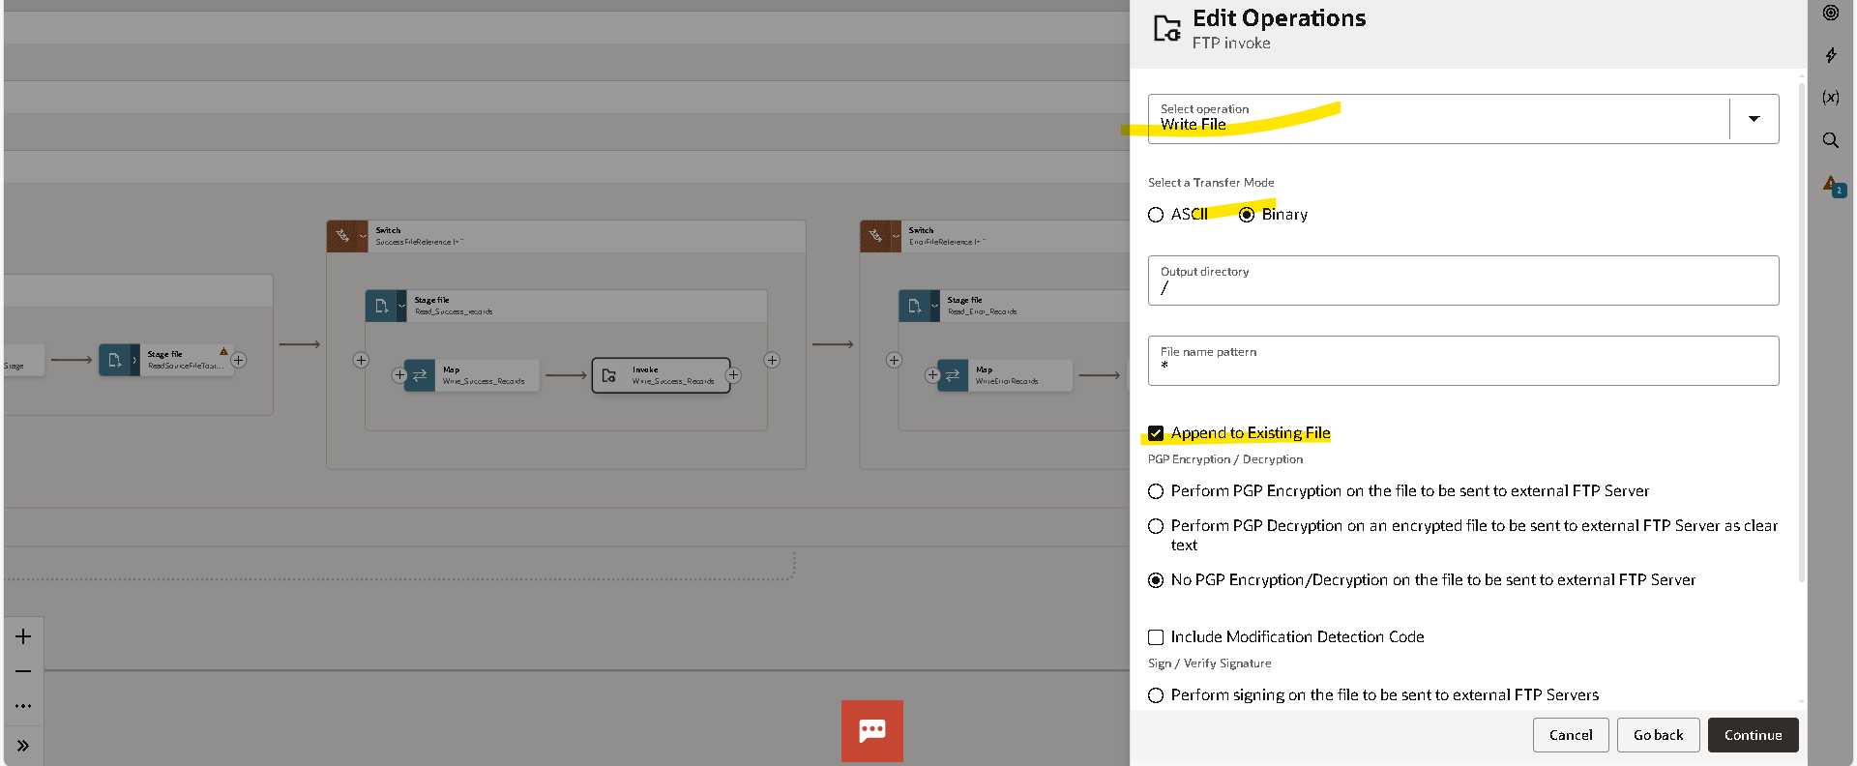
Select the operation as Write file
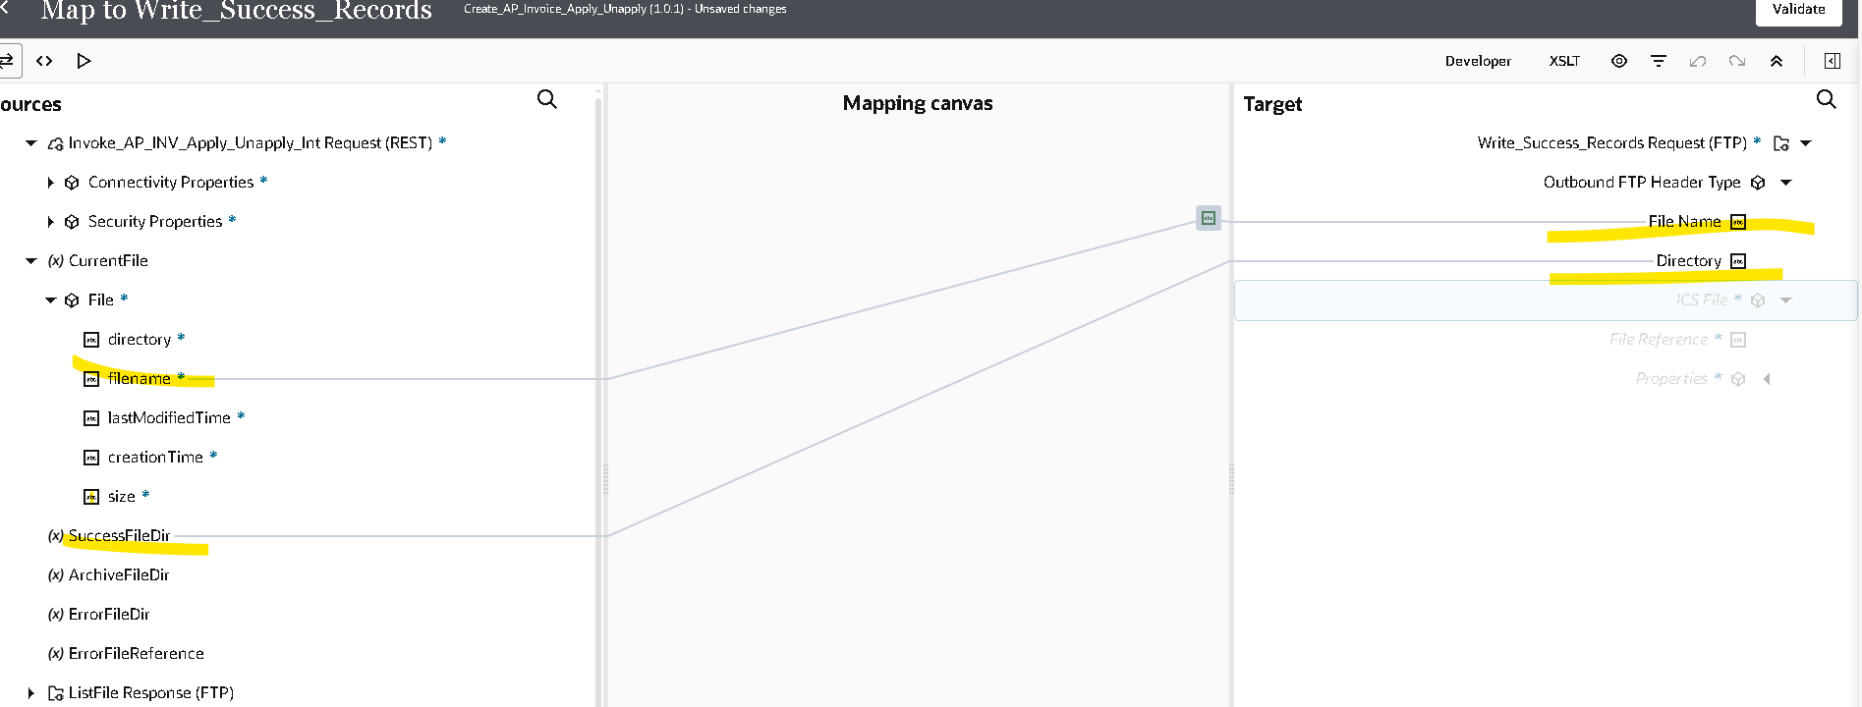
Map the data
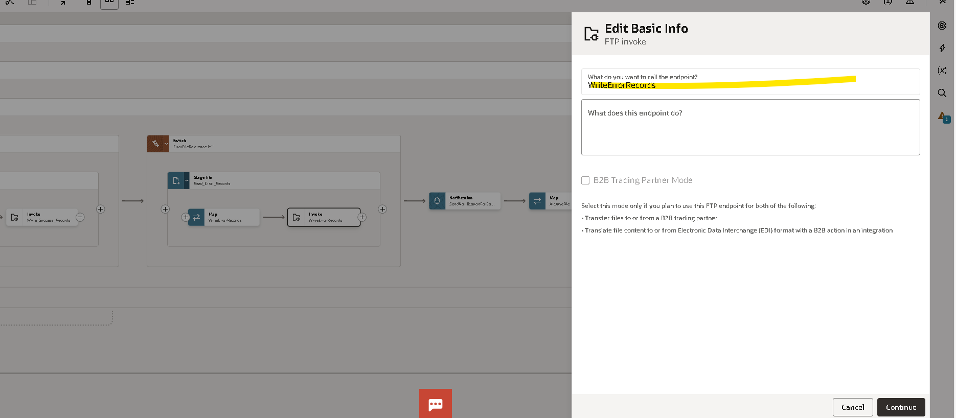
Using the FTP connection to read the error file
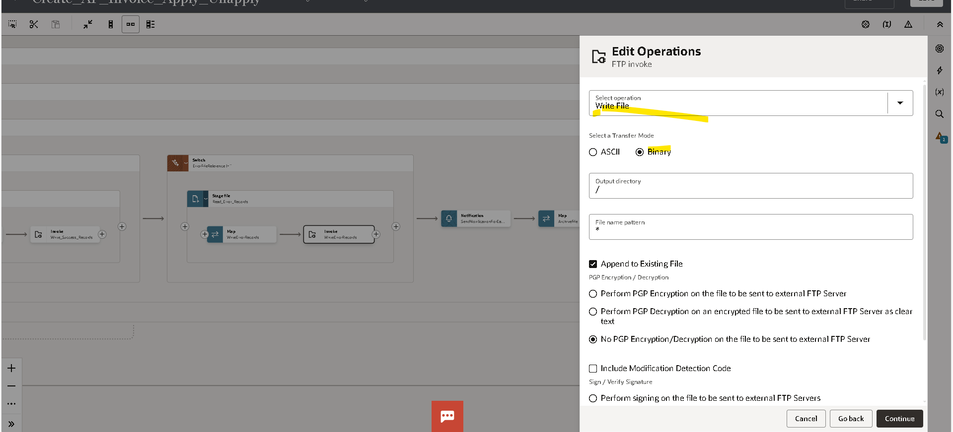
Select the Operation
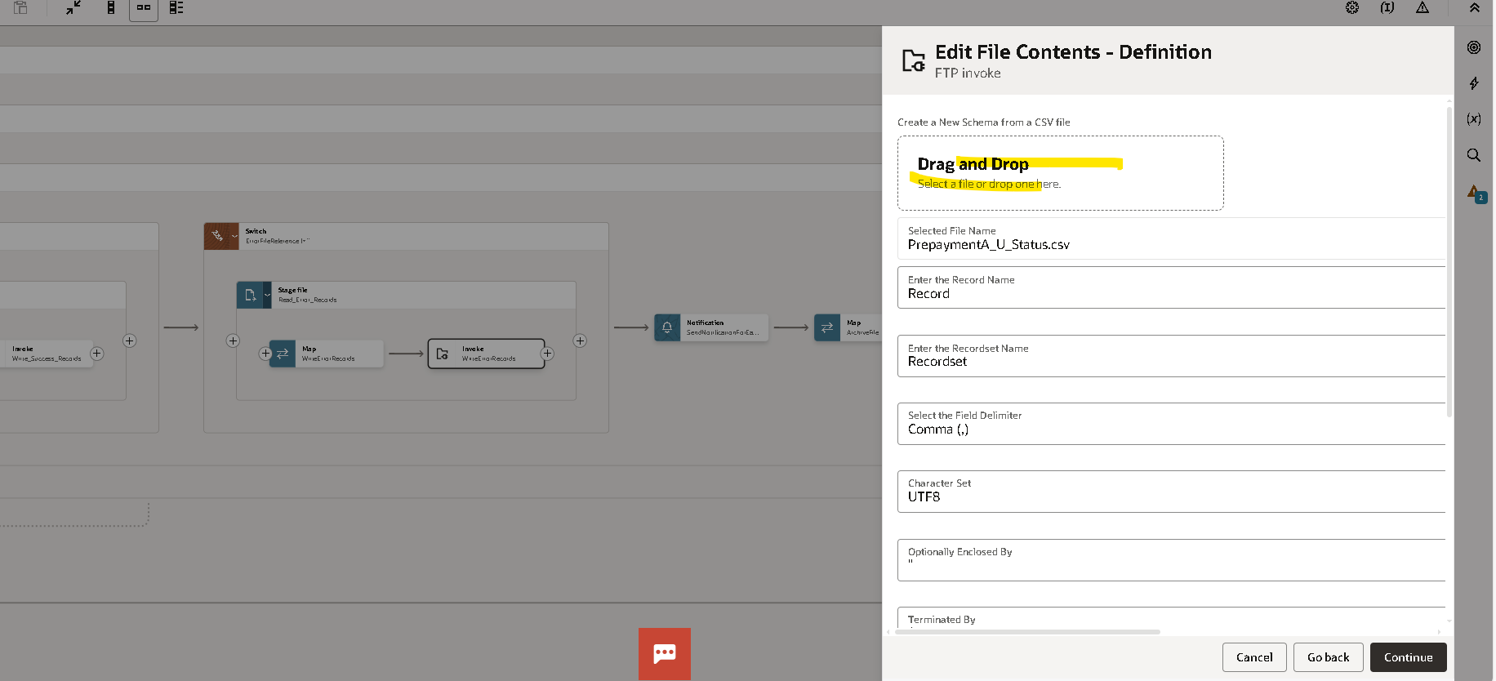
Give a file reference
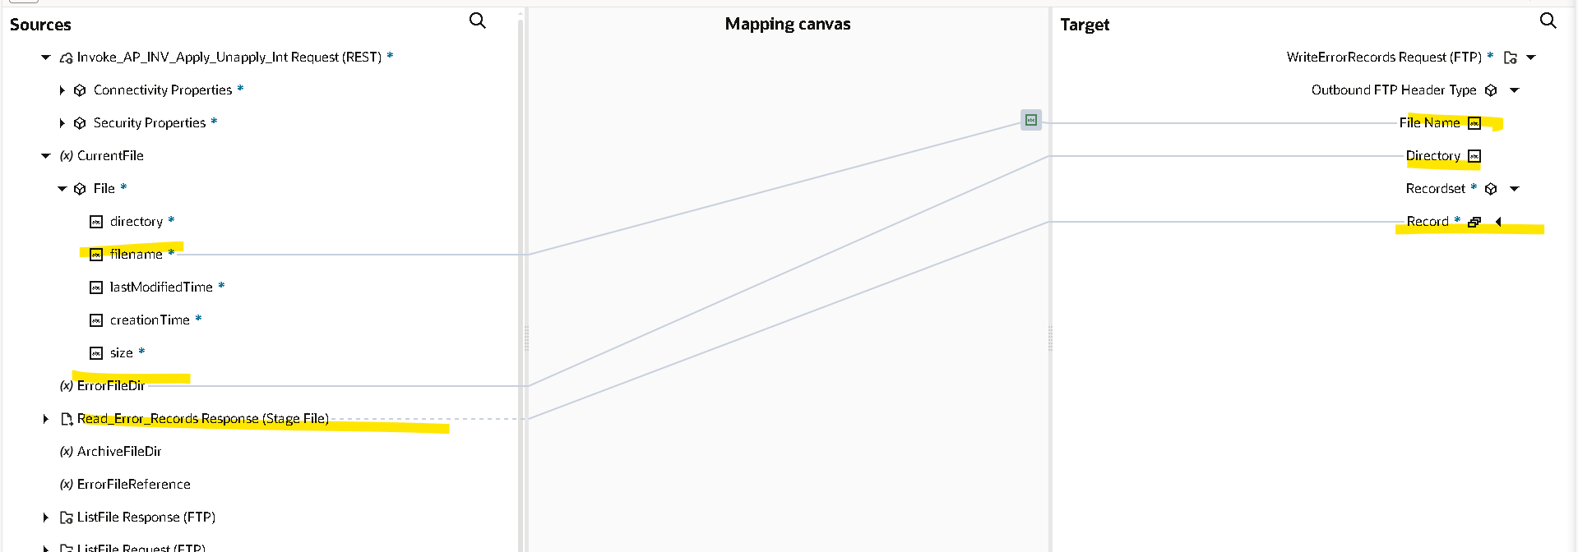
Map the data
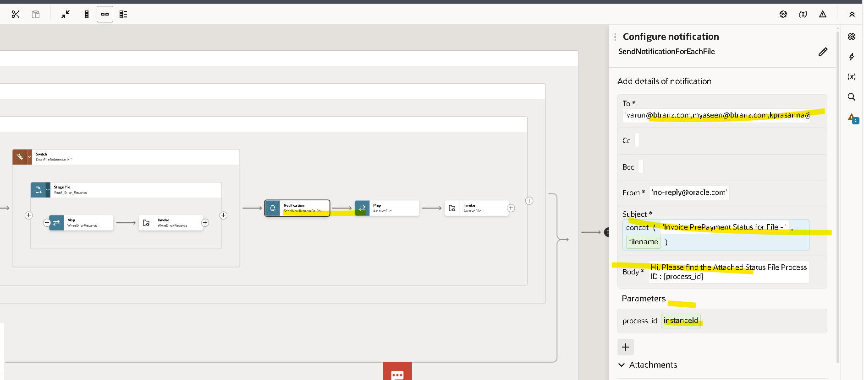
Select Notification to send the mail
- Give a mail body
- Subject

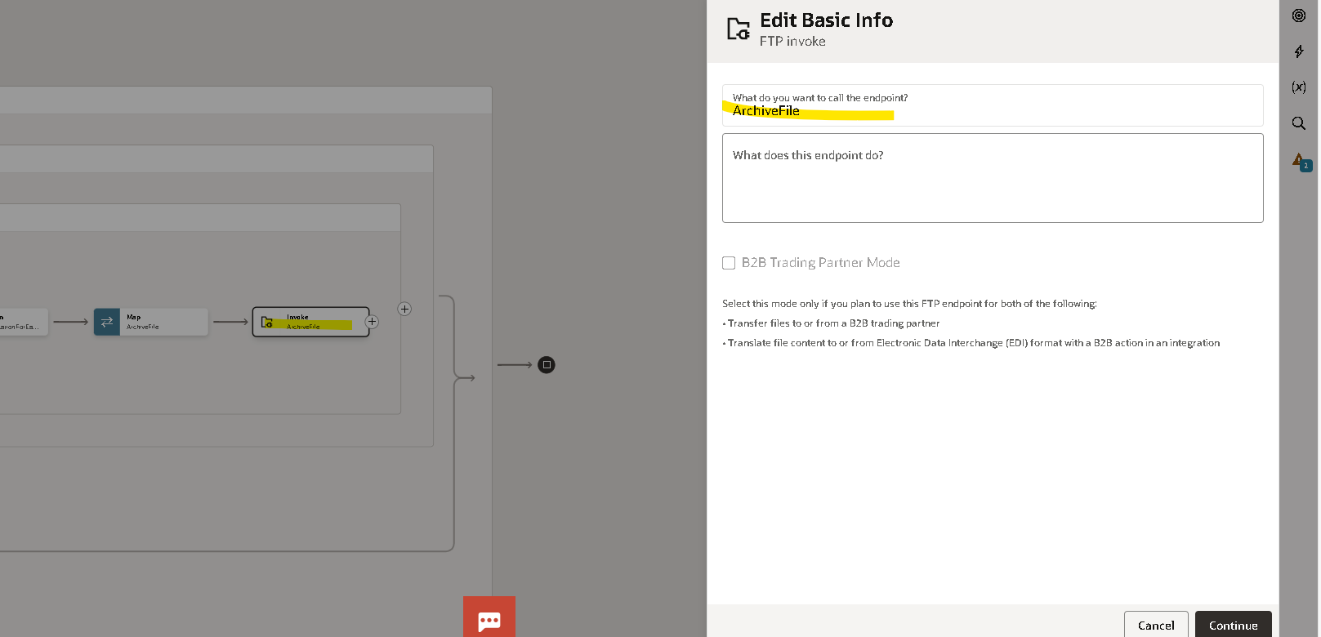
Using the FTP Connection To store Archive file
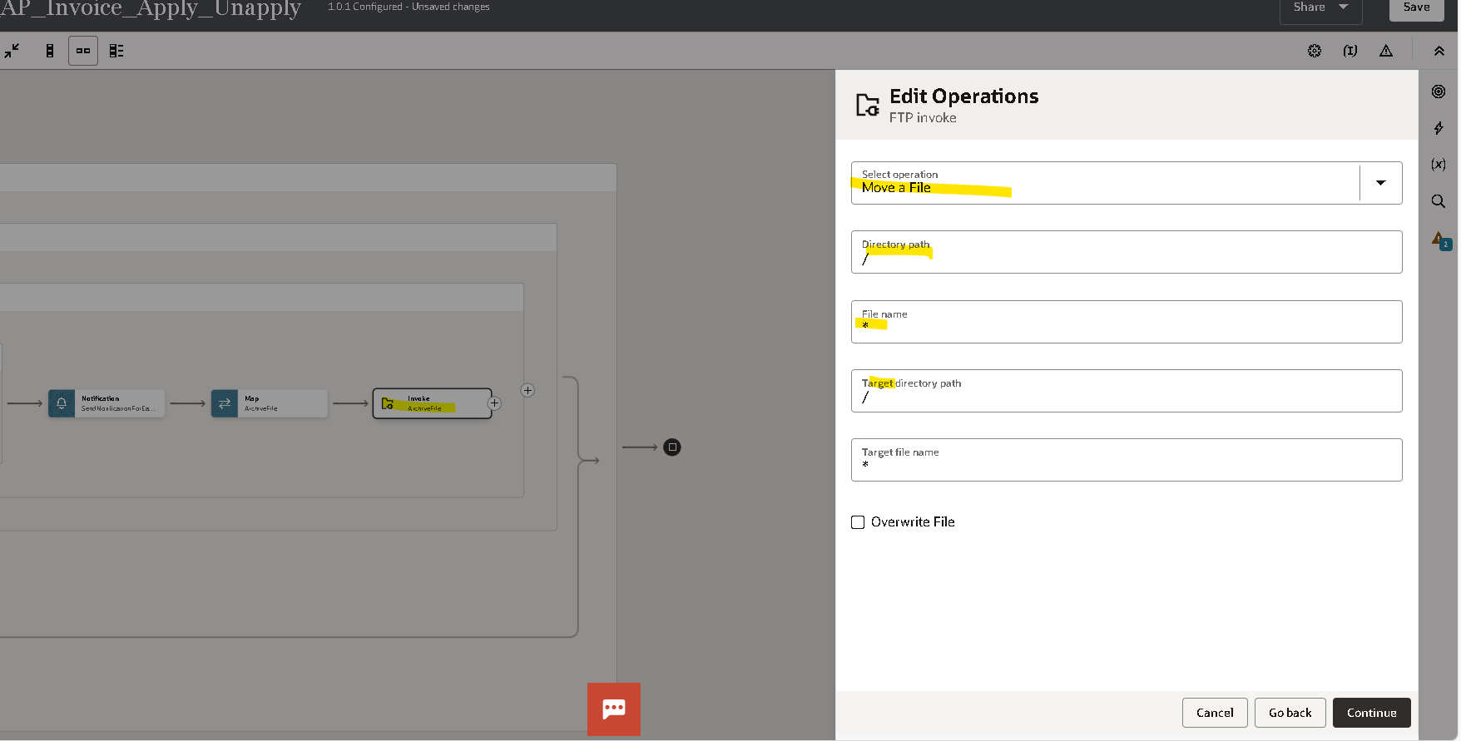
Select the operation as Move a file
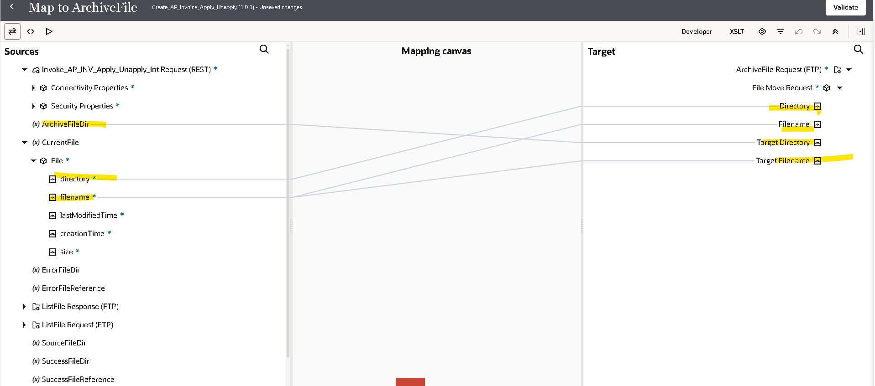
Map the data

